Name: __________________________________

Period: __________________________________

Date: ____________________________________

Concepts In Biology Field Study
He’eia

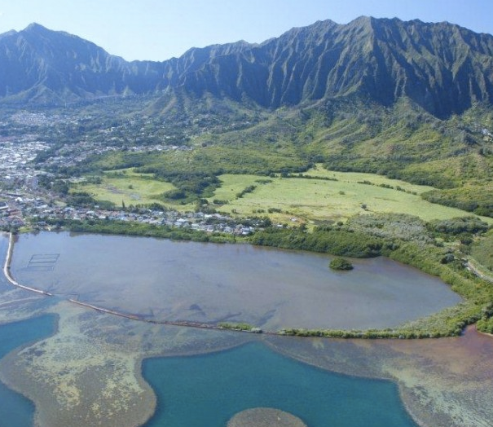

Ahupuaʻa of Heʻeia

Papahana Kuaola
Heʻeia Fishpond

Table of Contents

What to Bring 3
Schedule 3
Detailed Schedule 4-5
A. Breakout Session #1 8:30-11:45 a.m. 4-5
B. Breakout Session #2 12:15-2:15 p.m. 4-5
Field Trip Purpose & Objectives 6
Standards 7
Oli to Field Trip Sites 10
Report Format 11
Rubric 12
Geographic History of Heʻeia Area 13
Cultural Background of Heʻeia Area & Moʻolelo 15
Papahana Kuaola 16
Station 1: Cultural Activity 17
Station 2: Watershed of Riparian Habitat 24
Station 2: Water Quality of Riparian Habitat 26
Station 3: Zoology and Classification 31
Station 4: Community Service 40
About Heʻeia Fishpond 41
Station 5: Heʻeia Fishpond 42
Conclusion Requirements: 46

What to Bring

- 2-3 bottles of water
- Clothes willing to get dirty
- Towel & extra clothes
- Shoes, tabis, or reef walkers (no slippers or crocs till after field trip)
- Sunscreen
- Hat/Shades
- Snacks/Lunch (Sack Lunch will be provided)
- Small Backpack
- Digital or phone camera (3 per group)
- Zip Lock back for camera (if it rains)
- 1 plastic bag for wet clothes
- Pencil & Workbook

Schedule

April 23 (Tuesday)
Bus #1 – Miss Arce’s Class (pd 1)

Bus #2 – Mrs. Evensen’s Class (pd 3, 5)

April 24 (Wednesday)
Bus #1 - Miss Arce’s Class (pd 2)

Bus #2 - Miss Arce’s Class (pd 4, 8)

7:30-8:15 All groups leave Päkï Breezeway/Lunches picked up

8:15-8:30 Bathroom, Introduction, and Oli

8:30 -11:45 Breakout Session #1- Papahana Kuaola
- Station 1- Cultural Activity (All periods)
- Station 2- Water Quality of Riparian Habitat
- Station 3- Zoology and Classification
- Station 4- Community Service

11:45-12:15 Lunch

12:30-2:15 Breakout Session #2 – Heʻeia Fishpond
- Station 5- About fishponds and Invasive Species (All periods)

2:15- 2:45 Travel back to School

Detailed Schedule- April 23 (Tuesday)

A. Morning Sessions (8:15 – 12:15)- Papahana Kuaola

8:15 – 8:30- Introductions and History of Ahupuaʻa Heʻeia

8:30 – 9:00

Station 1: Cultural Activity (All Periods)

9:15-10:00

Station 2: Water Quality of Riparian Habitat (pd 1)

Station 3: Zoology and Classification (pd 3)

Station 4: Community Service (Rock Building or Pili Grass) (pd 5)

10:00-10:45

Station 2: Water Quality of Riparian Habitat (pd 5)

Station 3: Zoology & Classification (pd 1)

Station 4: Community Service (Rock Building or Pili Grass) (pd 3)

10:45-11:30

Station 2: Water Quality of Riparian Habitat (pd 3)

Station 3: Zoology & Classification (pd 5)

Station 4: Community Service (Rock Building or Pili Grass) (pd 1)

11:45-12:15 - Lunch

B. Afternoon Sessions (12:30 – 2:15)- Heʻeia Fishpond

12:30-12:45- Board Bus to Heʻeia Fish Pond to investigate flow of water

1:00-2:15- Station 5: About Heʻeia Fishpond & Invasive Seaweed

Detailed Schedule- April 24 (Wednesday)

A. Morning Sessions (8:15 – 12:15)- Papahana Kuaola

8:15 – 8:30- Introductions and History of Ahupuaʻa Heʻeia

8:30 – 9:00

Station 1: Cultural Activity (All Periods)

9:15-10:00

Station 2: Water Quality of Riparian Habitat (pd 2)

Station 3: Zoology and Classification (pd 4)

Station 4: Community Service (Rock Building or Pili Grass) (pd 8)

10:00-10:45

Station 2: Water Quality of Riparian Habitat (pd 8)

Station 3: Zoology & Classification (pd 2)

Station 4: Community Service (Rock Building or Pili Grass) (pd 4)

10:45-11:30

Station 2: Water Quality of Riparian Habitat (pd 4)

Station 3: Zoology & Classification (pd 8)

Station 4: Community Service (Rock Building or Pili Grass) (pd 2)

11:45-12:15 - Lunch

B. Afternoon Sessions (12:30 – 2:15)- Heʻeia Fishpond

12:30-12:45- Board Bus to Heʻeia Fish Pond to investigate flow of water

1:00-2:15- Station 5: About Heʻeia Fishpond & Invasive Seaweed

Field Trip Purpose & Objectives

Purpose:

“The purpose of the field trip is to observe and study the status and health of Waipao’s riparian habitat of Heʻeia Ahupuaʻa.”

Objectives:

- Students will use proper Hawaiian protocol to enter and present ho‘okupu (leis).

- Students will investigate the cultural significance and geology of the Heʻeia ahupuaʻa.

- Students will identify and classify native vs. non-native animals.

- Students will investigate how water quality of the river and loʻi in the area

- Students will learn from a traditional Hawaiian kumu about a cultural activity.

- Students will compare and contrast traditional methods of conservation/preservation with modern methods.

- Student will investigate how human activity has affected the area in both positive and negative ways.

- Students will understand the significance of “education” and learn how fragile our ecosystems are.

- Students will perform Project Restoration and community service by cleaning loʻi, river restoration, and removing invasive species

- Students will report and submit their scientific findings in this field trip.

Research Question:
Is the Waipao riparian habitat of Heʻeia ahupuaʻa a healthy ecosystem?

Hypothesis:

Standards

National Content Standards (Life Science 9-12)

Science as Inquiry

1.A. Gains an understanding that science is a process used to know more about the world around us.

1.B. Develops, practices, and applies the skills of questioning, observing, and experimenting.

1.C. Mathematics and technology are essential to scientific inquiry and for gathering data.

Interdependence of Organisms

2.A. Gains an understanding of the living world including form and function of organisms, diversity, life cycles, interactions and interdependencies.

2.B. The atoms and molecules on the earth cycle among the living and nonliving components of the biosphere.

2.C. Energy flows through ecosystems in one direction, from photosynthetic organisms to herbivores to carnivores and decomposers.

2.D. Organisms both cooperate and compete in ecosystems. The interrelationships and interdependencies of these organisms may generate ecosystems that are stable for hundreds or thousands of years.

2. E. Living organisms have the capacity to produce populations of infinite size, but environments and resources are finite. This fundamental tension has profound effects on the interactions between organisms.

2. F. Human beings live within the world's ecosystems. Increasingly, humans modify ecosystems as a result of population growth, technology, and consumption. Human destruction of habitats through direct harvesting, pollution, atmospheric changes, and other factors are threatening
current global stability, and if not addressed, ecosystems will be irreversibly affected.

Science in Personal and Social Perspectives

3.A. Populations grow and decline through the combined effects of births
and deaths, and through emigration and immigration. Populations can
increase exponentially, with the effects on resource use and environmental
pollution. (Example: Alien Invasive organisms)
3.B. Human populations use resources in the environment in order to maintain
and improve their existence. Natural resources have been and will continue
to be used to maintain human populations.

3.C. The Earth does not have infinite resources; increasing human consumption places severe stress on the natural processes that renew some resources, and it depletes those resources that cannot be renewed.

3.D. Many factors influence environmental quality.

3.E. Gains understanding of the role of science in his/her life including personal and community relationships, local and global challengers, and
environmental change.

‘Ike Hawai‘i Standards

- ʻŌlelo Hawai‘i
  - Students will Oli prior to entrance of the area.

- Hana No‘eau
  - Students will develop, practice, and apply the skills of observation, thinking, listening, imitating, modeling, experimenting, and questioning.
  - Understand our Hawaiian culture as a system of beliefs, knowledge, and practices shared by our people for the purpose of appreciation particular forms of arts.

- Ke Ao Nei
  - Through visiting the area students will understand and appreciate our relationship to our homeland from the perspective of the Hawaiian worldview and use this knowledge to care for our homeland.

- ‘Ohana
  - Students will work with classmates to understand traditional concepts of ‘ohana in terms of roles, responsibilities, practices, beliefs, and protocol.

Hawaiian Language Competencies

- Customs & Traditions

  - Students will sing entrance, greeting, and giving chant while at the field trip site.

- Society

  - Geography & Society- Students will identify significant historical places and facts.

  - Geography & Society- Students will identify significant historical events, explain their historical impacts, and explain their impact in today’s society.

  - Science- Identify native plants and animals and explain their cultural significance.

  - Science- Students will participate in and reflect upon culturally significant activities involving the ecosystem. Investigate and analyze the impacts of the role of each element/aspect/layer.

  - Science- Students will participate in sustaining and restoring the balance of the ecosystem by cleaning the area of study.

- Community, Land, & Sea

  - Students will perform community service by cleaning and restoring the field study area.

WEO (Working Exit Outcomes)

- Ke Ao Hoʻoūlu (Growth)-
  - Embrace my identity as a Hawaiian
  - Grow by identifying strengths and needs and pursuing appropriate actions

- Ke Ao Pilina (Relationships)- Adapt successfully to various kūlana

- Ke Ao Lani, Ke Ao Honua (Global)-
  - Live in interdependence with all surrounds me physically, spiritually, emotionally, and intellectually.
  - Embrace the collective experience as Hawaiʻi and the Pacific as a foundation for relating to the diversity of the world.
  - Nurture and value my identity as a source of understanding, purpose, meaning, and connection to others
- Ke Ao ʻImi Naʻauao- Knowledge and Wisdom
  - Utilize various sources (kupuna, kumu, moʻolelo, wahi pana, etc.) to foster inquiry and seek knowledge
  - Engage in critical thinking to apply traditional knowledge to my contemporary context

Oli to Field Trip Sites

E Hömai

E hömai ka ‘ike mai luna mai ē
ʻO nä mea huna no‘eau o nä mele ē
E hömai, e hömai, e hömai ē (repeat 3x)

Grant me knowledge from above
Of the Elusive words of wisdom within the chants
Grant me, grant me, grant me

Oli Kähea

Kü äkea nä kamalei
I ke anu o ka ‘öpua
Nä pua Kukui a Pauahi
I ke ao mälamalama
E maläma mai, e maläma mai ‘ē

The beloved children (of Pauahi) stand openly
In the chill of the billowing clouds
Kukui blossoms of Pauahi
Take care of us, take care of us…

Oli Mahalo

ʻUhola ʻia ka makaloa lā
Pū ʻai i ke aloha ā
Kū kaʻi ʻia ka hā loa lā
Pāwehi mai nā lehua
Mai ka hoʻokuʻi a ka hālāwai lā
Mahalo e Nā Akua
Mahalo e nā kupuna lā, ʻeā
Mahalo me ke aloha lā
Mahalo me ke aloha lā

The makaloa mat has been unfurled
In love, (food is/was shared) we share
The great breath has been exchanged
Honored and adorned is the Lehua
From zenith to horizon
Gratitude and thanks to our Akua
Gratitude and thanks to our beloved ancestors
Gratitude, admiration, thanks, and love
To all who are present, both seen and unseen

REPORT FORMAT (1 per team)

Instructions: Choose your team members (5-8 per team). Designate a team captain and delegate responsibilities of each team member. In addition, assign which team member(s) will be in charge in answering and typing which section in the FINAL REPORT.

Names of Team members: Period: _______ Cell #

1. _______________________________ (captain) ____________________

2. _______________________________ ____________________

3. _______________________________ ____________________

4. _______________________________ ____________________

5. _______________________________ ____________________

6. _______________________________ ____________________

7. _______________________________ ____________________

8. _______________________________ ____________________

Assign and delegate who will be in charge of each section.

Water Quality Section: Zoology

- pH - ____________________________ 1. Habitat Manager- _____________________

- Temperature- _____________________ 2. Habitat Manager- _____________________

- Phosphate- _______________________ 3. Vertebrate Zoologist- __________________

- Phosphate- _______________________ 4. Vertebrate Zoologist- __________________

- Nitrate- __________________________ 5. Invertebrate Zoologist- _________________

- Nitrate- __________________________ 6. Invertebrate Zoologist- _________________

- Dissolved O₂- _____________________ 7. Entomologist Zoologist- ________________

- Coliform- ________________________ 8. Entomologist Zoologist- ________________

Community Service:

1. Pili Grass: ________________________________________________________________________

2. Rock Building:______________________________________________________________________

Report Format (Must be typed in the same font and size)
- Cover Page: Title, class, period, picture of the place, and the names of all team members.
- Table of Contents. Also make sure each page has a page number.
- Cover Page with tabs for each section.
- Cultural Activity: Retype questions in analysis and include answers.
- Water Quality: All data tables are retyped with data and units if applicable. Questions with answers to analysis questions are typed, which includes five line graphs.
- Zoology & Classification: All data tables are retyped with data and units for each section if applicable. Questions with answers to analysis questions are typed.
- Community Service: Retype questions in analysis and include answers.
- Heʻeia Fishpond: Retype questions in analysis and include answers.
- Conclusion- Write a thorough conclusion (see questions on page 46-47) that summarizes the overall findings of each section and answer to the research question.

RUBRIC (100 points)

Group Member Names: _________________________________ Period: _____

________________________________________________________________

Criteria | Excellent | Average | Poor | Group Score
Cover Page, Introduction of site purpose, and hypothesis  (5 pts) | Contains picture, title, period, group members’ names, introduction, purpose & hypothesis. (4-5 pts) | Missing ONE of the components. (2-3 pts) | Missing TWO or more components. (0-1 pt)
Cultural Activity  (10 pts) | Content is precise. Pictures included and answers to analysis questions are accurate and thorough. (8-10 pts) | Some content is questionable and answers to analysis questions are minimal. (5-7 pts) | Most/All content is questionable and answers to analysis questions are missing. (0-4 pts)
Water Quality of Riparian Habitat  (20 pts) | Content is precise. Answers to analysis questions are accurate and thorough. Includes data table and graphs. (16-20 pts) | Some content is questionable and answers to analysis questions are minimal. Graphs and data tables are present, but not as thorough. (11-15 pts) | Most/All content is questionable and answers to analysis questions are missing. Graphs and/or data tables are missing.  (0-10 pts)
Zoology & Classification  (20 pts) | Content is precise. Pictures included and answers to analysis questions are accurate and thorough. Includes data table and graphs. (16-20 pts) | Some content is questionable and answers to analysis questions are minimal. Pictures, graphs and data tables are present, but not as thorough. (11-15 pts) | Most/All content is questionable and answers to analysis questions are missing. Pictures, graphs and/or data tables are missing. (0-10 pts)
Mälama ÿÄina  (Community Service at Papahana Kuaola)  (10 pts) | Participated in community service up. Reflection is insightful and thorough. Includes pictures  (8-10 pts) | Participated in community service up. Reflection is somewhat insightful. Includes pictures, but some are missing (5-7 pts) | Participated in community service up. Reflection is somewhat vague and incomplete. Includes pictures, but some are missing. (0-4 pt)
Heʻeia Fishpond  (10 pts) | Content is precise. Pictures included and answers to analysis questions are accurate and thorough.  (8-10 pts) | Some content is questionable and answers to analysis questions are minimal. (5-7 pts) | Most/All content is questionable and answers to analysis questions are missing. (0- 4 pts)
Summary Conclusion;  (20 pts) | Thorough analysis of the study site that includes insightful conclusion and evidence that shows whether or not hypothesis was supported. (16-20 pts) | Somewhat thorough analysis of the study site that includes a conclusion and statement of evidence that shows whether or not hypothesis was supported. (11-15 pts) | Analysis of the study site was lacking and statement of evidence that shows whether or not hypothesis was supported is unclear. (0-10 pts)
Grammar, spelling, font, neatness & References  (5 pts) | No grammatical or spelling errors. Also used the correct font, and report is neat and organized. References of books, Internet sites and picture citations included. (4-5 pts) | Some grammatical and spelling errors. Font is incorrect. Report is somewhat neat, somewhat organized. Some references are included. (2-3 pts) | Many grammatical and spelling errors. Font incorrect. Report is not neat, unorganized. NO references provided. (0-1 pt)
Comments:  Total Score:  % & Letter Grade |  |  |  | _____/100

Geographic History of Heʻeia Area

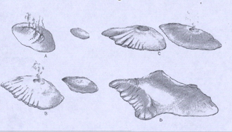
The volcanoes of the Hawaiian Island chain are called shield volcanoes, for their gently rounded, dome-shaped profiles. Shield volcanoes are built of lavas that erupt quietly, with little explosion, and spread rapidly from the vent and are called basaltic rocks.

The two volcanoes that made O‘ahu were Wai‘anae Volcano and Ko‘olau Volcano (Figure 1). The present island of O‘ahu came into being about 10 million years ago when the top of the Wai‘anae volcano broke the surface of the Pacific. So, the Waiÿanae volcano is much older than the Ko‘olau volcano. The caldera (or crater) of the Wai‘anae volcano sank to form a broad crater and with erosion, caused the valleys of the Western
Figure 1: Volcanic activity of Waiÿanae and Koÿolau Volcanoes of Oÿahu

side of Oÿahu on the Wai‘anae side to become much bigger than those on the Schofield side.

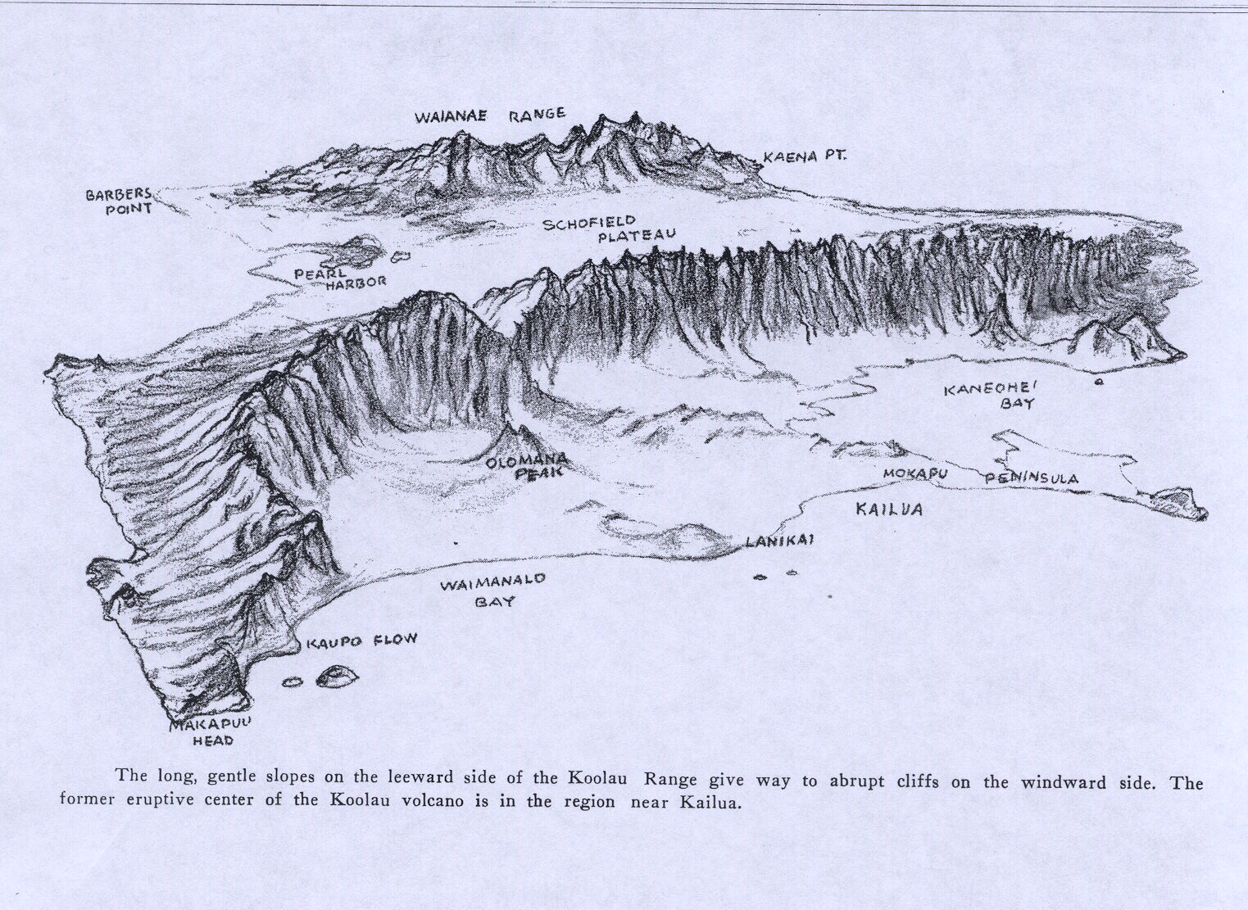
The Ko‘olau volcano appeared a few million years later as a separate island a few miles of the Wai‘anae. Both the Wai‘anae and Ko‘olau continued erupting causing for lava flow. The eruptions of both volcanoes formed more land eventually unifying to form one single island. Then, the Wai‘anae volcano became extinct and so did the Ko‘olau volcano. Like the Waianae volcano, the caldera (or crater) of the Ko‘olau volcano also sank below the ocean. With time, rain, and erosion, the remaining slopes of the Ko‘olau volcano became more steep and jagged (Figure 2)
Figure 2: The caldera of the Ko‘olau volcano sank below the ocean. Time, erosion, and rain have caused the cliffs of the Pali to be very steep and jagged.

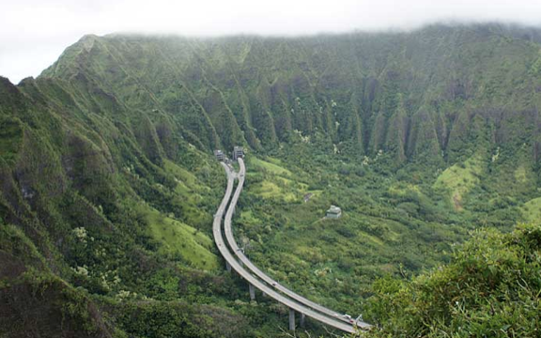
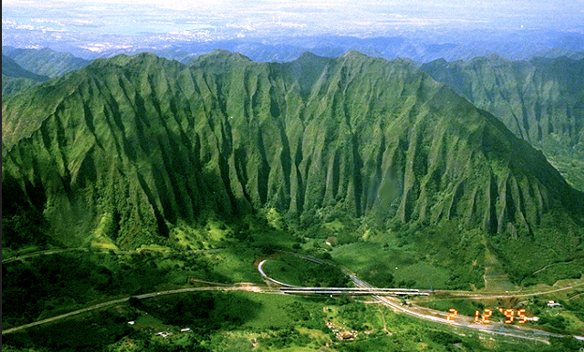

History & Background of Heʻeia

History of Koʻolaupoko (Windward Oʻahu)
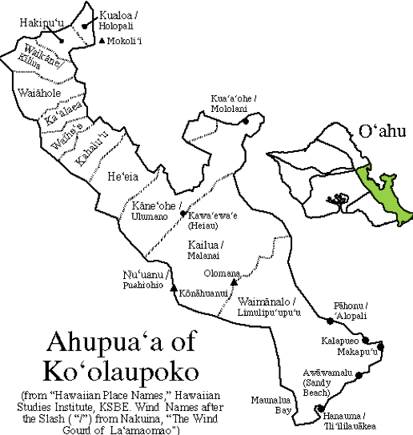
The first Polynesians arrived in Hawaiʻi sometime around the 5th century A.D., sailing thousands of miles across the vast Pacific Ocean, from the southwestern regions where Tahiti, New Zealand, and the Society Islands reside. They were seasoned, experienced sailors with a wealth of knowledge of the winds, the ocean currents and the heavens. With no form of written language, all of their experiences were remembered and passed on to the following generations orally, sometimes through songs (mele), dances (hula), or chants (oli). It is uncertain as to when these first peoples eventually settled on the windward side of Oʻahu (east Oʻahu), but archaeological evidence confirms their existence in the 13th century A.D.
Heʻeia
The windward side of Oʻahu is made up of two districts: Koʻolauloa (long Koʻolau) to the north, and Koʻolaupoko (short Koʻolau) to the south. These districts are bordered on the west by the entire ridge of the Ko`olau Mountain range. Within each
district there are several land divisions called ahupuaʻa, which extend from the mountain ridges to beyond the reefs offshore. The land was divided this way so that families could have access to the provisions of both the land (ʻāina) and the sea (kai). Koʻolaupoko, that region which encompasses Kaneʻohe Bay, is divided into nine ahupuaʻa, with Kualoa being the northernmost (and smallest), and Kaneʻohe being the southernmost (and largest). From north to south the nine ahupuaʻa are Kualoa, Hakipuʻu, Waikane, Waiahole, Kaʻalaea, Waiheʻe, Kahaluʻu, Heʻeia, and Kaneʻohe. Each ahupuaʻa includes a water portion of the bay, which extends seaward to the barrier reef boundary.

Heʻeia Ahupuaʻa:

In Hawaiian, the word ahupuaʻa refers to the land division from the mountain to the sea. This allowed for everyone in the ahupua'a to have access to the water resources at every elevation. The Heʻeia Ahupuaʻa includes Haiku and Iolekaʻa Valleys and extends to include a large portion of Kaneohe Bay. It includes Loko Iʻa O Heʻeia (Heʻeia Fishpond), which is an ancient Hawaiian kuapa or shoreline pond constructed in the late 1400s. It also includes Ka Lae O Kealohi (point of shining light, which is now known as Heʻeia State Park.

The word heʻeia means "washed out". This ahupua‘a extends over a broad area with its southern peninsula on the south end, ranging north to portions of ‘Ahuimanu and bordering Kahalu‘u.

The following is a Hawaiian legend explanation of the formation of this area and how it got its name, along with some other legends involving the Heʻeia Ahupuaʻa. From the Mo‘olelo Kahikono Hawai‘i, published in Hoku o Hawai‘i in 1928, is this passage: “Haumea moved to Pali-ku. She went to get Olopana‘s grandson to rear and named him He‘eia, because they had been washed out to sea. The place adjoining Kane‘ohe was named for him.

In ancient times, Heʻeia was called Ka Lae O Kealohi, the point of shimmering light. It is an elevated peninsula overlooking Kaneohe Bay. This is sacred ground, the site of an ancient Hawaiian heiau, Kalaeʻulaʻula. The Heiau was destroyed in the 1800s, but the essence of this special place still remains and endures.

The Heʻeia Fishpond, "Loko Iʻa O Heʻeia", can be seen from the point. A cultural artifact, the fishpond is a living testimony to the unique engineering capabilities of early Hawaiians. Using gravity flow, the pond receives the algae rich effluent form the taro patches. The park serves as the Friends' natural and cultural classroom. Within the park and a one-half mile radius, one can study a mountain stream, wetland, fishpond, coral reef, and historic site.
Ha‘iku Valley is said to have once served as the “hospital for Ko‘olaupoko”, where the kahuna la‘au lapa‘au gathered their medicinal plants for healing the people. Hidden beneath today‘s invasive species are likely to be yet unknown plants with excellent medicinal qualities

Moʻolelo
During a battle between the people of Koʻolaupoko and the people from Leeward Oʻahu, a large tidal wave washed the natives out to sea. Among those washed out were the goddess Haumea and her husband Wakea. When the kahuna saw them in trouble, he told Wakea to cup his hands together to represent a heiau. He did this and placed a humuhumunukunukuapuaʻa in the center to represent a sacrificial pig. The people swam in circles around him to dedicate the heiau. As soon as this was done, they were washed back to shore, making them victorious in the battle, thus fulfilling a prophecy that had been made before the battle. Haumea then moved to Palikū and went to get the grandson of a man named ʻOlopana. She raised him and named him Heʻeia, which meant "washed out", named after the people who had been washed out to sea in the area.

In old times, Heʻeia was a judging place for souls. The souls were divided into two groups, the white (who went to Heʻeia-Kea) and the black (who went to Heʻeia-Uli). The difference is similar to the difference between what we know as heaven and hell. The souls jumped from these points into the sea. The Hawaiians believed that these points were entrance points to the after life.

On the Mauka side of the road through the Heʻeia area is a small area of land known as Luamo'o. Here lived Meheanu, the Kiaʻi, or watch guard of the Heʻeia fishpond. Meheanu had supernatural powers and could change herself into many forms, such as a frog or a lizard, but her favorite form was that of an eel. Around Luamoʻo were many hau trees, which sheltered the home of Meheanu while she was a lizard, or moʻo. When the hau was yellow, then the people in the area were sure that Meheanu was there as a lizard, but when the hau was green, then she was more likely to be somewhere else in the form of an eel.

Kaualehu Cave is seen high on the pali walls above Ha‘iku Valley, times, a beautiful woman named Kameha‘ikana once dwelled in the area and stayed at the cave of Kaualehu.

In neighboring Iolekaʻa Valley is found Lealeahina Heuia, still cared for by native Hawaiian families to this day. The lands of the rats and the pool that is located at the foot of the pali. The kama‘aina rats are said to have tricked the intruders into falling into the pool and drowning. They say you can always tell the malahini rats from the kama‘aina – the rats of He‘eia have red feet; the malahini rats‘ feet are black or white.

About Papahana Kuaola

Papahana Kuaola is a non-profit organization providing the community with educational opportunities that are integrated with traditional and contemporary Hawaiian knowledge. The programs on Oʻahu and Molokaʻi allow people to connect and re-connect with the land, culture, and its values.
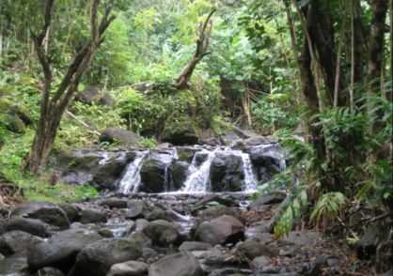
The Mission at Papahana Kuaola is to create quality educational programs focused on environmental restoration and economic sustainability fully integrated with Hawaiian knowledge in order to exemplify a lifestyle respectful of kānaka, ‘āina, and akua. Founded in 2007, with programs existing on Oʻahu and Molokaʻi. Home based in Heʻeia with land mostly leased from Kamehameha School Bishop Estate. Currently we are focusing on replanting native Hawaiian species and restoring the ancient Hawaiian characteristics back into the landscape.
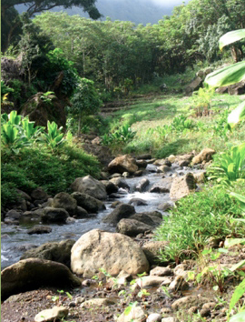
Our hands-on learning experiences take place primarily at this site and include: native plant propagation; invasive species removal; reforestation; stream studies; ethno-biology; cultural and historic site management; learning and perpetuating native Hawaiian cultural traditions; and applying these values, skills, practices, and principles in a modern world. We strive to develop new relationships, and work to strengthen existing partnerships with other community organizations on environmental initiatives and native Hawaiian species restoration projects throughout the State.
Currently, Papahana Kuaola is involved in a four-year project to restore about 4000ft of riparian habitat in upper Heʻeia Stream. In addition to reforesting with native vegetation, the project includes installation of erosion control techniques to address eroding stream banks, and monitoring water quality pre and post project implementation and educational workshops. Volunteers will help by clearing areas of non-native species and debris, spreading mulch, planting native species and maintaining planted areas. In the future, community groups will be able to utilize this project as an educational experience.

Station 1: Cultural Activity

Topic: Ka Wai A Kāne, “Where are the Water’s of Kāne?”

Introduction: We will learn about how important water is to Hawaiʻi in the areas of society (kanaka), the environment (ʻāina), and spirituality (akua). This discussion will lead into the rotating stations preparing the students (haumana) to see how data collection and observation helps in the perpetuation of Hawaiian practices and lifestyles.

Take Notes on the Speaker Below:

Station 2: Watershed of a Riparian Environment

About Heʻeia Stream and Watershed

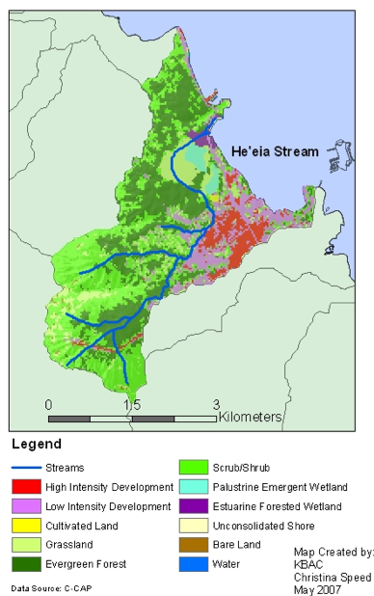
The Environmental Protection Agency defines a watershed as any body of land that flows downhill into a waterway. Basically, "watershed" is a broad term used to describe how water flows across land to feed streams, rivers and lakes (source: Environmental Protection Agency). All of these watersheds fit together like puzzle pieces to form our landmasses.
A watershed can be thousands of square miles, or it can be a few acres draining into a pond (source: Environmental Protection Agency) here are millions of watersheds in the world - 2,100 small ones in the United States alone (source: Nature Serve). However, a watershed is more than just a piece of land that collects the rainwater and dumps it into the river. Anything that ends up in a watershed ends up in a body of water, including pollutants like discarded motor oil or paint, or sediments from trees cut down due to construction. These and other pollutants can contaminate a water supply, erode the land surrounding the body of water and disrupt aquatic habitats.
Heÿeia watershed occurs on the island of Oʻahu. The Hawaiian meaning of the name is “washed (as being swept to sea)”. The area of the watershed is 3.5 square mi (9.1 square km), with maximum elevation of 2723 feet (830 m). The watershed's DAR cluster code is 4, meaning that the watershed is medium size, steep in the upper watershed, and with embayment. The percent of the watershed in the different land use districts is as follows: 0% agricultural, 56.6% conservation, 0% rural, and 43.4% urban.
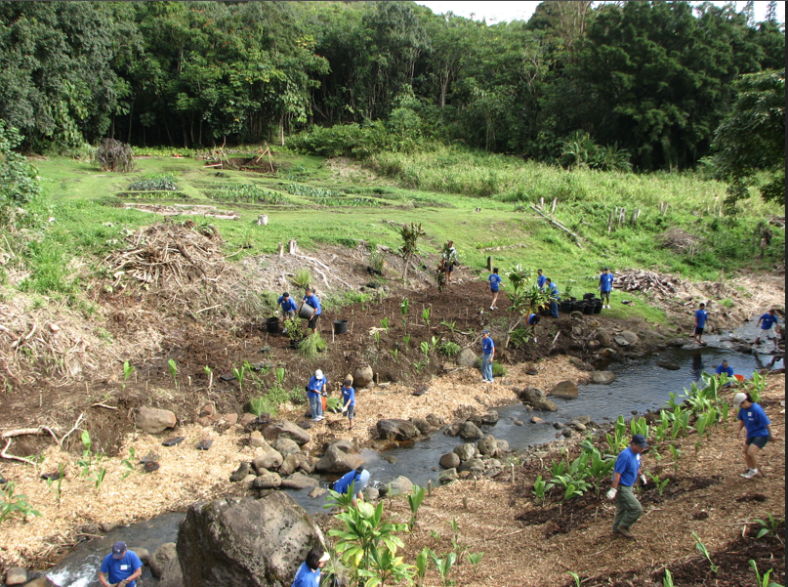
HEʻEIA STREAM FEATURES
Heÿeia is a perennial stream, which means that the stream flows continuously throughout the year and has steady water supply. Total stream length is 7.1 mi (11.5 km). The terminal stream order is 2.
Reach Type Percentages: The percentage of the stream's channel length in each of the reach type categories.
Estuary Lower Middle Upper Headwaters
0.0 21.7 66.1 12.2 0.0

CURRENT WATERSHED AND STREAM RATINGS

Introduction: The current watershed and stream ratings are based on the data in the Department of Aquatic Resources (DAR) database. The ratings provide a score for the individual watershed or stream, the distribution ratings of the island, and distribution of ratings statewide. The ratings are standardized to range from 0 to 10 (0 is lowest and 10 highest) for each variable and the totals are also standardized so that the rating is not the average of each component rating. Note the data below was published in April 7, 2008.

Watershed Rating: Heʻeia Oʻahu

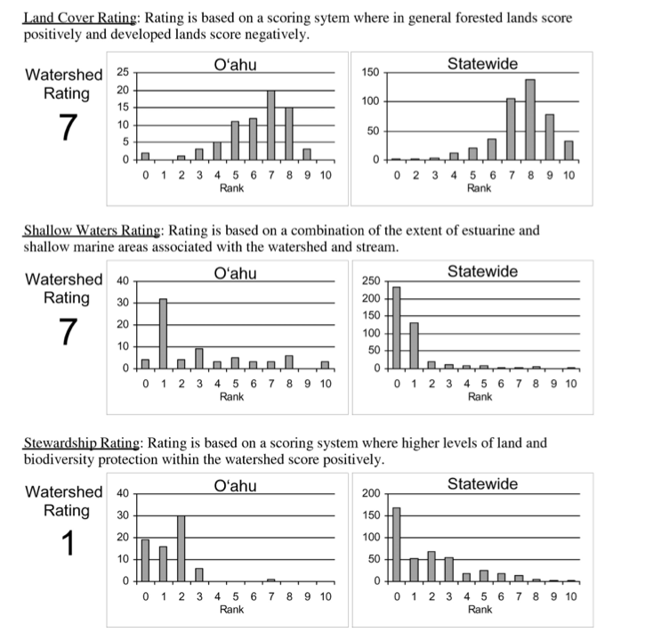

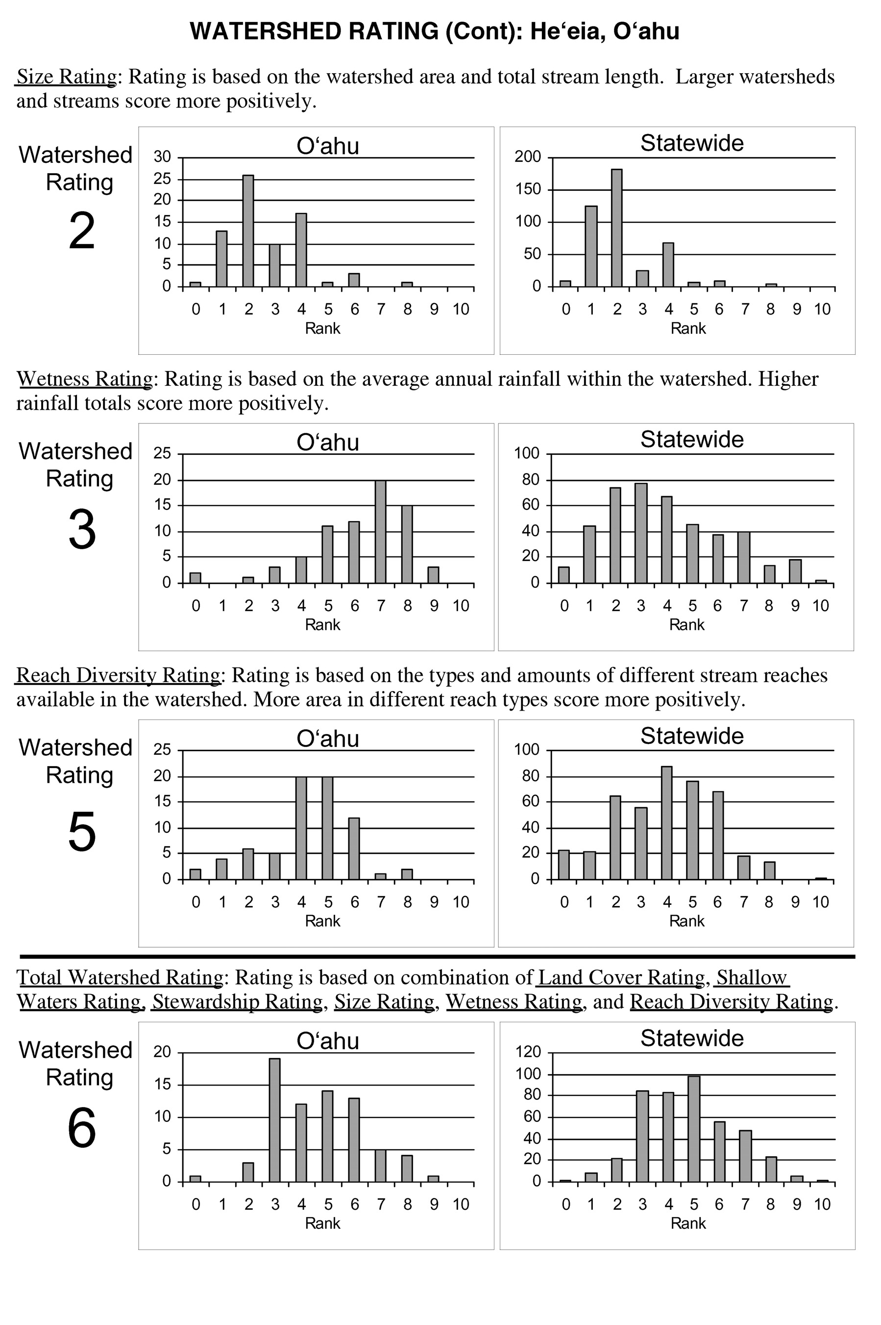
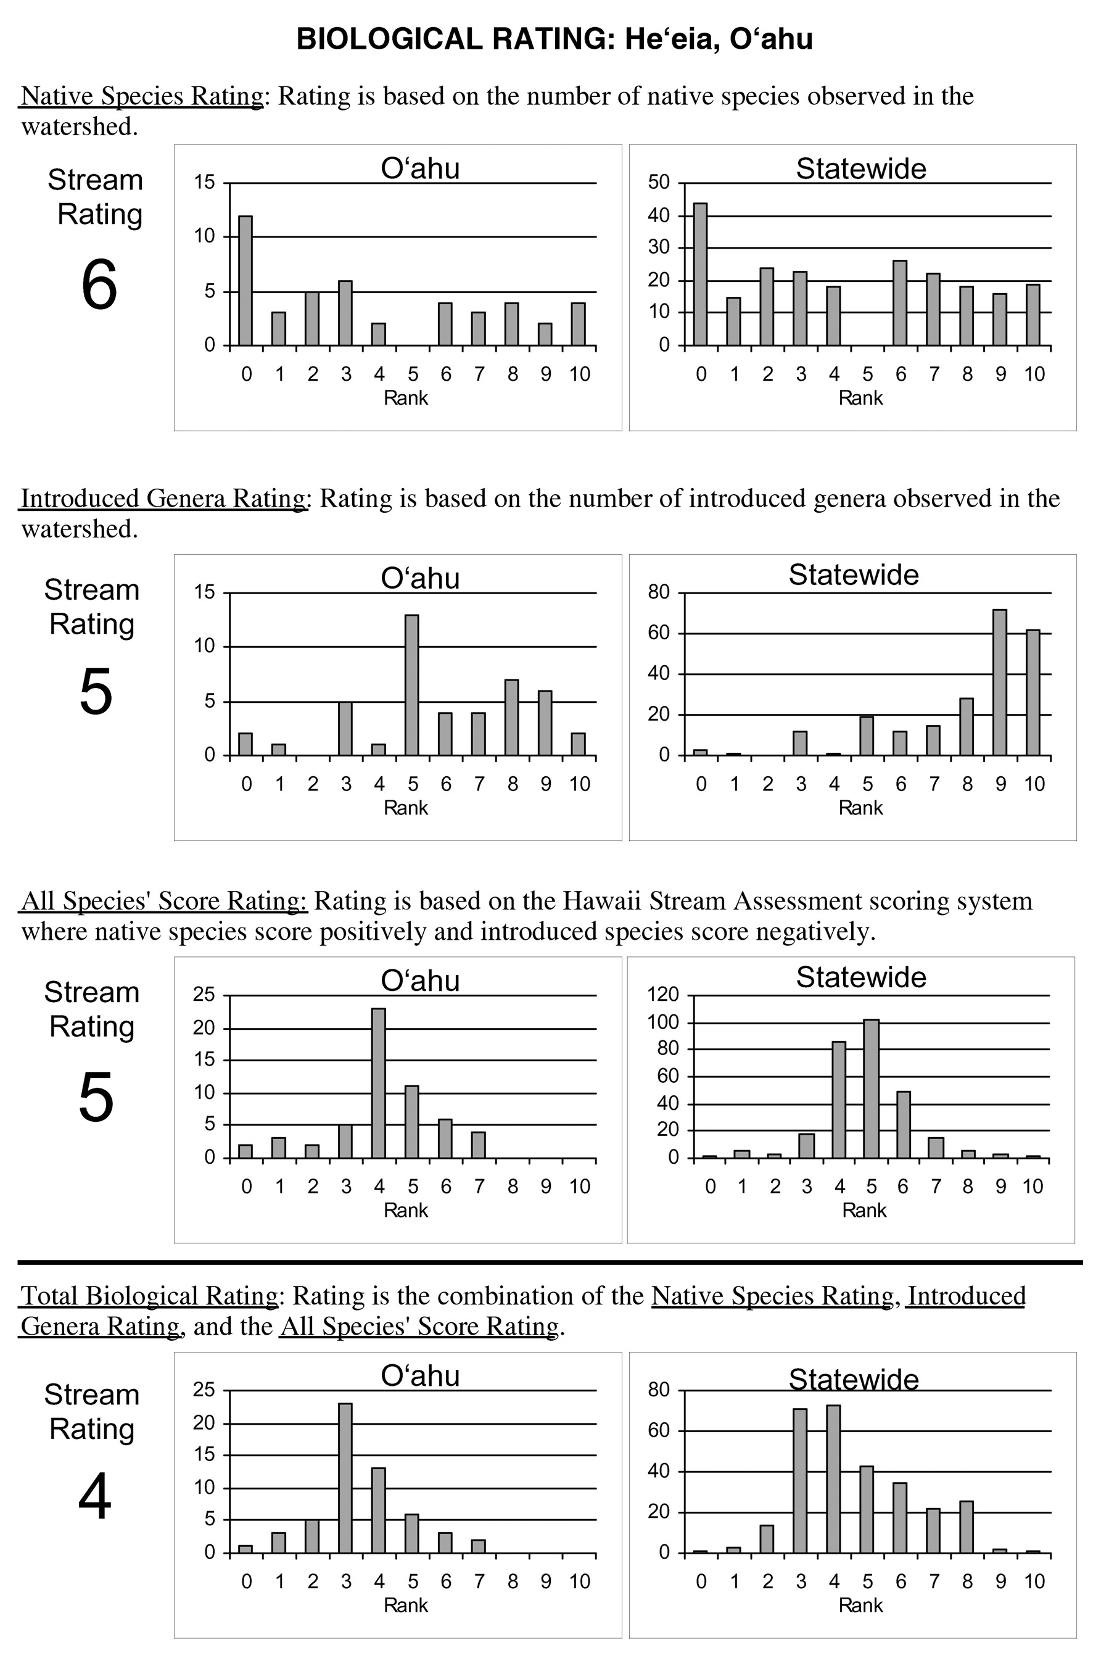
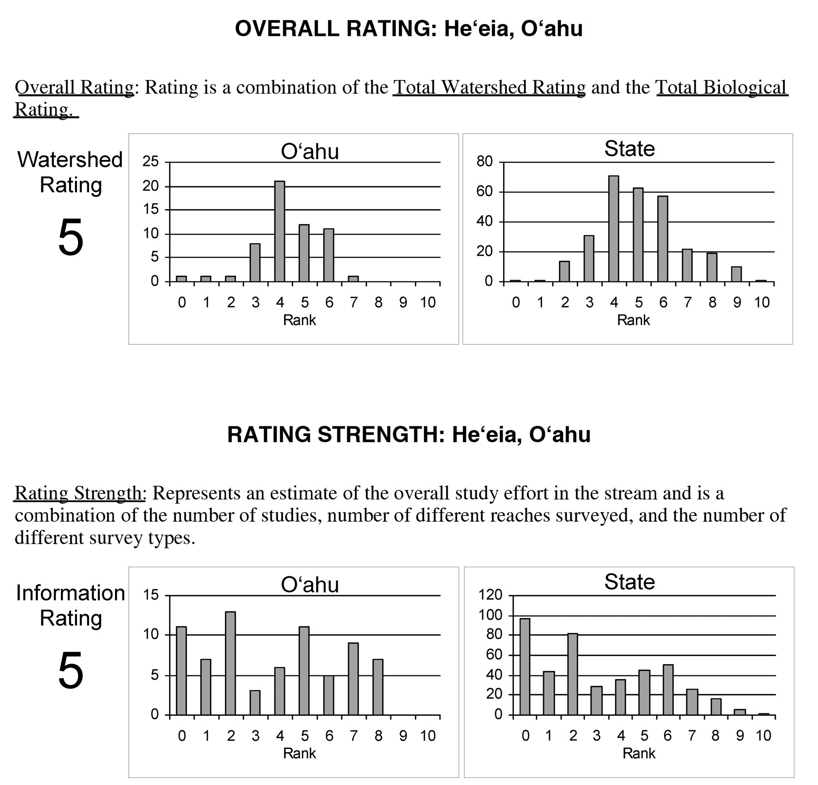

Analysis Questions:Answer in complete sentences

- Based on the study above, which areas in the watershed section had the lowest scores?

- What factors do you think are causing a poor rating score in these sections? (Be specific).

- According to the the data above, the total watershed rating is 6, which is somewhat average. Suggest three specific solutions that could help improve the overall score of Heʻeia watershed?

Station 2: Watershed of a Riparian Environment

HEʻEIA RIPARIAN STREAM ENVIRONMENT

Riparian zones have been defined in various ways, but essentially they consist of fairly narrow strips of land bordering creeks, rivers, lakes, or other bodies of water. Plant species, soil types, and topography are distinctive when compared to the surrounding, drier upland area.
Although riparian areas generally occupy only a small percentage of the area of a watershed, they are crucial components of the ecosystem. A healthy riparian area: provides excellent fish and wildlife habitat; increases groundwater recharge; reduces flooding; and often increases the overall quality of the adjacent waterway.
A riparian stream includes vegetated ecosystems along a water body through which energy, materials, and water pass. Riparian areas characteristically have a high water table and are subject to periodic flooding and influence from the adjacent water body. These systems encompass wetlands, uplands, or some combination of these two landforms.

HOW RIPARIAN STREAMS ARE CHANGED AND AFFECTED

Water quality of riparian streams and habitat can be altered by the following ways by pollution, trash, erosion, rain, wildlife (pigs, cattle, goats, etc.), mud, flooding, run-off, invasive species, debris, dams, diversion, agriculture lands, development, clearing of land, mining, etc. The characteristics above can damage wildlife, alter ecosystem, and change the river flow of water. Thus, a healthy watershed will prevent flooding, erosion, and increase diversity of wildlife and many more.

Part 1- Observing Loʻi Riparian Environment:

Directions: Look at the study area and along the riverbanks. Your task is to complete the chart based on your observations. When you have completed the chart, you have identified the typical qualities that make a riparian system either healthy or degrade. Check the appropriate column if the area is naturally disturbed, human disturbed, mixed (natural and human), and no disturbance based on your observation.

Table 1: Characteristics of Riparian Habitat and Stream
 | Naturally Disturbed | Human Disturbed | Mixed Disturbance (Natural and Human combined) | No disturbance
Bank Vegetation
Stream Flow
Water Quality
Habitat
Grass for grazing animals
Wildlife Diversity
Bank Stability (slopes of land)
Land for agriculture or development
Invasive Species
Debris (Trash, trees, leaves, etc.)
Rocks/Gravel/Soil/
Boulders
Run-off (pesticides, herbicides, rain, etc.)

Part 1 Analysis- Loʻi Riparian Environment

Directions: Answer the questions in complete sentences.

- Name 5 (five) important features of a healthy riparian habitat? (See table 1 for hints).

- Name three characteristics that identify how watershed(s) are protected from erosion and why?

- How are streamside plants important to fish, bank stability, and prevention from erosion? What does it do?

- How do watersheds affect the water quality of a water system?

- What human activities damage the health of watersheds? What activities improve the health of watersheds?

Station 2: Water Quality of a Riparian Environment

Part 2- Water Quality: Water quality is very important. It explains the health and state of the water and its ecosystem. In this section, your team will determine if there are differences or similarities in the water quality of each loʻi patch starting from the main awai to the last loʻi patch.

- pH- measures how acidic, basic, or neutral of water . Most freshwater lakes, streams, and ponds have a normal pH in the range of 6 to 8.

Research Question: What will happen to pH levels as water flows down the stream and into and out of loʻi and awai? Will it become more acidic, basic, or neutral?

Hypothesis: _____________________________________________________________

_______________________________________________________________________

- Temperature- measures the current temperature of the water in Celsius. If temperature too hot, it causes death to aquatic life and also reduces oxygen levels. Normal temperature of freshwater is around 20-28 °C.

Research Question: What will happen to temperature levels as water flows down the stream and into and out of loʻi and awai? Will it become colder, warmer, or stay the same?

Hypothesis: _______________________________________________________________

________________________________________________________________________

- Phosphate (PO₄)- measures the amount of phosphorus in the water. Levels must be kept to a minimum, even though phosphate is a major nutrient for corals. Ideal phosphate levels should < 0.2ppm for fish systems or <0.01ppm for coral reef. If over > 0.2 ppm then algae will grow more often and can lead to eutrophication.

Research Question: What will happen to phosphate levels as water flows down the stream and into and out of loʻi and awai? Will it become more, less, or stay the same?

Hypothesis: _______________________________________________________________

________________________________________________________________________

- Nitrate (NO₃) - Nitrate is a major ingredient of farm fertilizer and is necessary for crop production. Nitrates stimulate the growth of plankton and waterweeds that provide food for fish. This may increase the fish population. However, if algae grow too wildly, oxygen levels will be reduced and fish will die. Favorable nitrate levels should be below 12.5 g/mL, 12.5- 25 g/mL still good, but invertebrates could be sensitive. 25-50 g/mL, can be critical for some invertebrates, but still ok for fish. Above 50 g/mL is hazardous for marine organisms.

Research Question: What will happen to nitrate levels as water flows down the stream and into and out of loʻi and awai? Will it become more, less, or stay the same?

Hypothesis: _______________________________________________________________

________________________________________________________________________

- Dissolved Oxygen (O₂)- Dissolved oxygen analysis measures the amount of gaseous oxygen (O2) dissolved in an aqueous solution. Oxygen gets into water by diffusion from the surrounding air, by aeration (rapid movement), and as a waste product of photosynthesis. Adequate dissolved oxygen is necessary for good water quality. Oxygen is a necessary element to all forms of life. Natural stream purification processes require adequate oxygen levels in order to provide for aerobic life forms. As dissolved oxygen levels in water drop below 5.0 mg/l, aquatic life is put under stress. The lower the concentration, the greater the stress. Oxygen levels that remain below 1-2 mg/l for a few hours can result in large fish kills.

Research Question: What will happen to oxygen levels as water flows down the stream and into and out of loʻi and awai? Will it become more, less, or stay the same?

Hypothesis: _______________________________________________________________

________________________________________________________________________

- Coliform- Coliforms are a group of bacteria (Faecal streptococci), which are also indicators of sewage contamination. Negative result shows purple color. Positive result shows yellow color, which means fecal matter is present in the water.

Research Question: What will happen to coliform levels as water flows down the stream and into and out of the loʻi and awai? Will fecal coliform be present or not?

Hypothesis: ________________________________________________________________

_________________________________________________________________________

Procedures: Don’t forget to take pictures of this station
- Take 500 mL water samples from 6 locations using a water bottle provided
- Site Locations:
  - Site 1- Spring Water Source
  - Site 2- Terrace # ____ and Loʻi ___
  - Site 3- Terrace # ____ and Loʻi ___
  - Site 4- Terrace # ____ and Loʻi ___
  - Site 5: Terrace # ____ and Loʻi ___
  - Site 6- End of Spring Source

- Use the water sample gathered from each location to perform the following tests below. See the box for detailed instructions as to how to perform each test

Data:

Table 2: Group Data Period _______ Date of Collection: ____________

Site | pH | Temp  (°C) | Phosphate PO₄  (ppm) | Nitrate  NO₃  (mg/L) | Dissolved O  (mg/L) | Coliform  (+= yellow)  (- = purple)
Normal Levels | 6-8 | 20-28°C | Below  0.2 ppm | Below 12.5 g/mL | Above  5.0 mg/L | - (negative)
Site 1:
Spring Source
Site 2:
Terrace #___
Loʻi #___

Kalo Variety:

Site 3:
Terrace #___
Loʻi #___

Kalo Variety:

Site 4:
Terrace #___
Loʻi #___

Kalo Variety:

Site 5:
Terrace #___
Loʻi #___

Kalo Variety:

Site 6:
End of Awai

Table 3: pH Average Class Data Date of Collection: ____________

Sites  Normal Levels  pH 6-8 | Site 1:  Spring Source | Site 2:  Terrace #___  Loʻi #___  Kalo Variety: | Site 3:  Terrace #___  Loʻi #___  Kalo Variety: | Site 4:  Terrace #___  Loʻi #___  Kalo Variety: | Site 5:  Terrace #___  Loʻi #___  Kalo Variety: | Site 6:  End of Awai
Period ___
Period ___
Period ___

Average

Table 4: Temperature Average Class Data Date of Collection: __________

Sites  Normal Levels 20-28°C | Site 1:  Spring Souce | Site 2:  Terrace #___  Loʻi #___  Kalo Variety: | Site 3:  Terrace #___  Loʻi #___  Kalo Variety: | Site 4:  Terrace #___  Loʻi #___  Kalo Variety: | Site 5:  Terrace #___  Loʻi #___  Kalo Variety: | Site 6:  End of Awai
Period ___
Period ___
Period ___

Average

Table 5: Phosphate Average Class Data Date of Collection: __________

Sites  Normal Levels  Below  0.2 ppm | Site 1:  Spring Source | Site 2:  Terrace #___  Loʻi #___  Kalo Variety: | Site 3:  Terrace #___  Loʻi #___  Kalo Variety: | Site 4:  Terrace #___  Loʻi #___  Kalo Variety: | Site 5:  Terrace #___  Loʻi #___  Kalo Variety: | Site 6:  End of Awai
Period ___
Period ___
Period ___

Average

Table 6: Nitrate Average Class Data Date of Collection: __________

Sites  Normal Levels  Below  12.5 mg/L | Site 1:  Spring Source | Site 2:  Terrace #___  Loʻi #___  Kalo Variety: | Site 3:  Terrace #___  Loʻi #___  Kalo Variety: | Site 4:  Terrace #___  Loʻi #___  Kalo Variety: | Site 5:  Terrace #___  Loʻi #___  Kalo Variety: | Site 6:  End of Awai
Period ___
Period ___
Period ___

Average
Table 7: Dissolved Oxygen Average Class Data Date of Collection: __________

Sites  Normal Levels  Above 5.0 mg/L | Site 1:  Spring Source | Site 2:  Terrace #___  Loʻi #___  Kalo Variety: | Site 3:  Terrace #___  Loʻi #___  Kalo Variety: | Site 4:  Terrace #___  Loʻi #___  Kalo Variety: | Site 5:  Terrace #___  Loʻi #___  Kalo Variety: | Site 6:  End of Awai
Period ___
Period ___
Period ___

Average

Table 8: Coliform Class Average Class Data Date of Collection: __________

Sites  Normal Levels  Negative  (-) | Site 1:  Spring Source | Site 2:  Terrace #___  Loʻi #___  Kalo Variety: | Site 3:  Terrace #___  Loʻi #___  Kalo Variety: | Site 4:  Terrace #___  Loʻi #___  Kalo Variety: | Site 5:  Terrace #___  Loʻi #___  Kalo Variety: | Site 6:  End of Awai
Period ___
Period ___
Period ___

Average

Analysis Questions:

- Use Excel or Create a Graph to make the 5 line graphs for the average pH per each site. X= site and Y= value in pH, Temp, Phosphate, Nitrate, and Oxygen).

- What was the average pH level for each test site? Were there any patterns in the pH levels as the water flowed down stream? Were the pH levels normal or not, explain (see table 3). Was your hypothesis supported or not, explain?

- What was the average temperature (°C) for each site? Were there any patterns in the temperature as the water flowed down stream? For example- colder or hotter? Were the temperature levels for each site normal or not, explain (see table 4). Was your hypothesis supported or not, explain?

- What was the average PO₄ (phosphate) level for each test site? Were there any patterns in the phosphate levels as the water flowed down stream? For example-increased, decreased, or stayed the same? Were the phosphate levels for each site normal or not, explain (see table 5)? Was your hypothesis supported or not, explain?

- What was the average NO₃ (nitrate) level for each test site? Were there any patterns in the nitrate levels as the water flowed down stream? For example-increased, decreased, or stayed the same? Were the nitrate levels for each site normal or not, explain (see table 6)? Was your hypothesis supported or not, explain?

- What was the average dissolved oxygen (O₂) level for each test site? Were there any patterns in oxygen levels as the water flowed down stream? For example-increased, decreased, or stayed the same? Were the oxygen levels for each site normal or not, explain (see table 7)? Was your hypothesis supported or not, explain?

- What were the results for the coliform test for each site? Were there any patterns in coliform? Explain, what could have caused the site to be positive for fecal matter? Was your hypothesis supported or not, explain?

Station 3: Zoology & Classification

Instruction: A wide range of plant and animal species occupy the Heʻeia area. For the purpose of the Zoology section, you will focus only on the animal species near or along Heʻeia stream at the facility we are visiting today. You will record the presence of species by visual observation, photography (phone or other cameras), sketches, lists, and collecting samples using nets and buckets. You will make an effort not to harm any of the organisms and when finished with our observations, return them gently to the location where found to minimize our impact. Each organism plays an important role in the environment that we wish to respect.

Preparation prior to the Field Trip. Persons per group = 4- 6.
- Get acquainted with your role. Research and read the student data book and online sources to discover how a
  - Zoologist (invertebrate and vertebrate)
  - Entomologist
  - Wildlife habitat manager
contributes to the well being of natural areas. Be able to say three things about their job
and how they provide a service to the community and help us personally.

- Tell other group members about your role. Define new terms and use them when describing your “profession.”

- Be prepared to help out and fill in if someone in your group is absent so that all tasks are completed during our field study. As a group, you will be ready to share with the class during our post-trip sessions.

Group Roles:

1) Group 1- Habitat managers, 3-6 students

Purpose: To count types of habitat and flow types available for stream species.
- This assessment measures availability of physical habitat for native Hawaiian stream organisms. The potential for the maintenance of a healthy animal community and its ability to recover from disturbance is dependent on the variety and abundance of suitable habitat and water flow available.
- Observe the number of different habitat and flow types at each site and record the score on the datasheet. Each flow type must be present in appreciable amounts to score.
- Equipment checklist: camera, clipboard, student data book, pencil, thermometer (degrees C °), counter, meter stick, and long tape measure for stream width.

- Group 2- Vertebrate Zoologists, 3-6 students

Purpose: To count and collect animals with backbones such as fish, frogs, tadpoles, birds, rats, pigs, dogs, cats, etc.
- Assess fish and other vertebrate abundance. Sample stream animals and assess species composition, for fish and tadpoles use dip nets. If you capture invertebrate species as by-catch, share them with the invertebrate zoologists.
- As for non-fish vertebrates, conduct visual observations for birds and signs of mammals (tracks, chewing marks) and take pictures of organisms if seen. If possible, ask people who work on site what animals have been seen on location over time (dogs, cats, pigs, etc). Record these as “reported” observations and include photos from online to complete your final report.
- Equipment checklist: clipboard, student data book, pencil, aquatic dip nets, hand lens, camera, 30 cm ruler, cups, bucket, animal cage/aquaria.

3) Group 3- Invertebrate Zoologists, 3-6 students

Purpose: To count and collect animals without backbones: worms, larvae, snails, crayfish, shrimp, etc.
- Collect specimens with aquatic dip nets, and benthic (steam bottom). Look under stones and beneath vegetation along stream banks where small organisms can hide. Conduct visual observations and take pictures of aquatic vertebrates. Shrimp have been seen in the loʻi around the grassy rim.
- Equipment checklist: camera, clipboard, student data book, pencil, dip nets, hand lens, camera/phone, 30 cm ruler, cups, bucket, small insect cage.

4) Group 4- Invertebrate Entomologists (Insects), 3-6 students

Purpose: To count and collect mites, spiders, insects, dragonflies, bugs, butterflies, damselflies, etc.
- Conduct visual observations and take pictures of aquatic insects or evidence of insects (webs, chewing marks, small holes in vegetation) in the area and above the water body. Sampling of damselflies and dragonflies (Odonata) is emphasized, as several of these are currently candidate threatened or endangered or endemic species. Note that aquatic mosquito larvae are insects as well.
- Collect both immature and adult specimens with aerial sweep nets and place them in cages for later observation. To do this, walk slowly through grassy areas and shrubbery using a wide sweeping motion back and forth in front of you at knee level. After a few minutes of collecting, grasp and hold the tip of the net upward to concentrate insects at the tip. This method is effective because insects will crawl or fly upward in an attempt to escape. With your other hand, collar the tip and close off the opening by grabbing an area below the insects. Have your partner position a cage within the net just beneath your closed fist that is holding the net shut. Slowly transfer insects by turning the net inside out into the cage. Have a partner ready to quickly close the cage as you draw out the tip of the net. Speed is of the essence.
- Equipment checklist: camera, clipboard, student data book, pencil, aerial sweep nets, hand lens, camera/phone, 30 cm ruler, cups, bucket, small insect cage.

Data Tables, “Zoology and Classification”

IV. RESULTS for Habitat Managers

How much habitat is available for species?
Directions: Refer to the bold-faced list to record the Habitat types observed at each site. Enter the habitat types on the Scoring Data Sheet.
Count the number of habitat types found at each site, refer to the chart below to find the Score, then enter the Score on bottom line of the Scoring Data Sheet for each site in the row where “Habitat Score” is written. A high score indicates good stream health and the presence of a variety of places for organisms to live. Scores range from 0 to 20.

Habitat types

- Seeps and Springs– Areas in the riparian area where there is groundwater input (cooling the water and providing habitat to native aquatic invertebrates).
- Pools – Areas characterized by smooth undisturbed surface, generally slow current, and typically deep (deep enough to provide protective cover for fish. Included in this habitat would be deep “plunge” pools at the base of a cascade or waterfall.
- Runs – Areas characterized by moving water, but no broken water surface or whitewater
- Riffles – Areas characterized by broken water surface, rocky or firm substrate, moderate or swift current, and relatively shallow depth (usually less than 18 inches). Generally, flow is fast and shallow.
- Cascades– Waterfalls, or basically steep riffles (greater than 3%gradient)

SCORING DATA SHEET
Date: | Time: |  | Weather:
Stream Name: Heʻeia Stream
Group Member Names: | Site A  Upstream | Site B  Puna, Spring | Site C  Loʻi, kalo patch | Site D  Lower stream, flat  grassy area
Average Stream Width at Site (meters)
Temperature °C

Habitat Types – List for each site if present
- Seeps/springs
- Pools
- Runs
- Riffles
- Cascades

Habitat Score

Chose a high score within the range if there are multiple numbers of each flow type at the site. Decide on a score in the higher range if there are numerous pools, runs or riffles versus one of each. The range of scores allows best professional judgment to suit each unique situation.

Condition | Score | Explanation
5 habitat types available | 2.0 | 1.8 - 2.0 Very High
4 habitat types available | 1.9-1.8 | 1.5 - 1.7 High
3 habitat types available | 1.7-1.0 | 1.1 - 1.4 Medium
2 habitat available | 0.5-0.2 | 0 - 1.0 Low
1 habitat type available | 0 | 1.5 - 1.7 High

IV. RESULTS for Vertebrate Zoologists
Site A- Upstream
Site B- Puna, Spring
Site C- Loʻi Kalo
Site D- Lower stream, flat grassy area

Record data below for vertebrate sightings by the different groups and other outside observers in the tables below:

Date: |  | Time: |  |  | Weather:
Site | Common Name of Vertebrate Species found | Scientific Name | Vertebrate Class: | Species Type:  Terrestrial=T  Aquatic=A  Sediment= S | Origin  Native=N  Introduced= I  Invasive= AI | Trophic Level:  Herbivore  Carnivore  Decomposer | Abundance:  Abundant (+++)  Common (++)  Rare (R)

Date:  Time:  Weather: |  | Place a check in the box if the animal is found at the  Site A, B, C, and/or D
List vertebrate animals you have found and classify them from simple to complex:  Species found: | Indicate the Class of each animal:  Osteichthyes (fish)  Amphibia (frogs, tadpoles)  Reptilia (lizards, geckos, Jackson chameleon)  Aves (birds, ducks, chickens)  Mammalia (pigs, rats, dogs, mongoose, cats, etc.) | Site A  Upstream | Site B  Puna, Spring | Site C  Loʻi, kalo patch | Site D  Lower stream, flat grassy area
IV. RESULTS for Invertebrate Zoologists
Site A- Upstream
Site B- Puna, Spring
Site C- Loʻi Kalo
Site D- Lower stream, flat grassy area

Record data below for invertebrate sightings by the different groups and other outside observers in the tables below:

Date: |  | Time: |  |  | Weather:
Site | Common Name of Invertebrate Species found | Scientific Name | Invertebrates by Phylum | Species Type:  Terrestrial=T  Aquatic=A  Sediment= S | Origin  Native=N  Introduced= I  Invasive= AI | Trophic Level:  Herbivore  Carnivore  Decomposer | Abundance:  Abundant (+++)  Common (++)  Rare (R)

Date:  Time:  Weather: |  | Place a check in the box if the animal is found at the  Site A, B, C, and/or D
List invertebrate animals you have found and classify them from simple to complex:  Species found: | Indicate the Phylum of each animal:  Platyhelminthes (flatworms)  Mollusca (snails, slugs,  Annelida (earthworms)  Arthropoda  (Class Crustacea) (shrimp, crayfish) | Site A  Upstream | Site B  Puna, Spring | Site C  Lo’i, kalo patch | Site D  Lower stream, flat grassy area
IV. RESULTS for Entomologists
Site A- Upstream
Site B- Puna, Spring
Site C- Loʻi Kalo
Site D- Lower stream, flat grassy area

Record data below for insects sightings by the different groups and other outside observers in the tables below:

Date: |  | Time: |  |  | Weather:
Site | Common Name of insects found | Scientific Name | Invertebrates by Phylum | Species Type:  Terrestrial=T  Aquatic=A  Sediment= S | Origin  Native=N  Introduced= I  Invasive= AI | Trophic Level:  Herbivore  Carnivore  Decomposer | Abundance:  Abundant (+++)  Common (++)  Rare (R)

Date:  Time:  Weather: |  | Place a check in the box if the animal is found at the  Site A, B, C, and/or D
List insects and other terrestrial arthropods you have found and classify them from simple to complex:  Species found: | Indicate the Class or  Order for each animal:  Class: Chilopoda (centipede)  Class: Diplopoda (millipedes)  Class Arachnida (spiders, scorpions, ticks)  Class: Insecta  Orders:  Orthoptera (grasshoppers, cockroaches, crickets)  Odonata (dragon fly, damselflies)  Homoptera (bugs)  Hemiptera (bugs)  Coleoptera (beetles)  Diptera (flies, mosquitoes)  Hymenoptera (bees, wasps, ants)  Lepidoptera (moths, butterflies) | Site A  Upstream | Site B  Puna, Spring | Site C  Lo’i, kalo patch | Site D  Lower stream, flat grassy area

Analysis Questions:

- Why are a variety of habitats important to ecosystems?

- What is meant by “stream health” with respect to the number of habitats found at a site?

- Give examples of two different food chains from producer to tertiary consumer from two different sites.

- Which type of vertebrate(s) dominated the area? Which were rare? (fish, birds, pigs, dogs, etc.) Explain why in your opinion were these animals dominant or rare?

- Were any of the vertebrates a threat to the environment and ecosystem, if so what negative effects do they have on the ecosystem, food web, or habitat?

- Which group of invertebrate(s) dominated the area? Which were rare? Explain why in your opinion were these animals dominant or rare?

- Were any of these invertebrate animals a threat to environment and ecosystem if so what negative effects do they have on the ecosystem, food web, or habitat?

- Were there more native or introduced living things in the area? Why do you think there was more of one than the other?

- Which, if any, human activities are affecting the area in a positive way? Explain the good effects.

- Which, if any, human activities are affecting the area in a negative way? Explain how these negative activities are affecting the ecosystem?

Station 4: Community Service

Instructions: You will be helping out in various community service projects throughout Papahana Kuaola (pili grass or rock building). Please be mindful of where you step. Follow instructions and be careful using the tools.

Analysis Questions: Answer using complete sentences!

- What did you learn about the amount of work it takes to up keep Papahana Kuaola?

- Why is Papahana Kuaola an important piece of the learning and practicing traditional Hawaiian practices?

- How is Papahana Kuaola a good example of sustainability? (Be specific and give examples).

- How did Papahana Kuaola affect you as a Hawaiian and your kuleāna to take care of the ʻāina? How did it teach you to be resourceful and sustainable?

About Paepae Heʻeia Fishpond

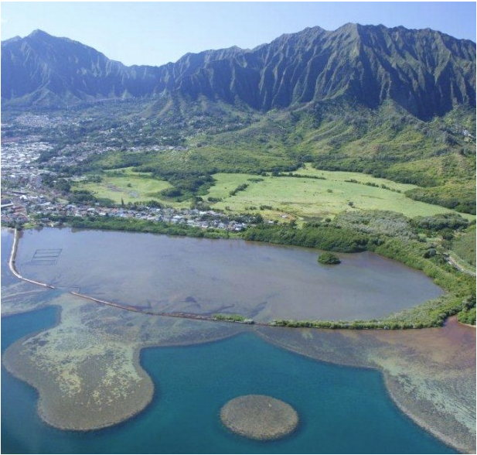
Paepae o Heʻeia is a private non-profit organization dedicated to caring for He'eia Fishpond – an ancient Hawaiian fishpond located in Heʻeia, Koʻolaupoko, Oʻahu. Established by a group of young Hawaiians, Paepae o Heʻeia works in partnership with landowner, Kamehameha Schools, to manage and maintain Heʻeia Fishpond for the community.

Paepae o Heʻeia was established to mālama Heʻeia Fishpond and serve as kiaʻi to this precious resource and treasure.
- Our vision is to perpetuate a foundation of cultural sustainability for communities (ʻohana) of Hawaiʻi through education.
- Our mission is to implement values and concepts from the model of a traditional fishpond to provide physical, intellectual and spiritual sustenance for our community.
To reach our vision, we utilize the strengths of the fishpond as a place of learning to weave ancestral knowledge together with Western ways of knowing to achieve our goals.

Mo’olelo

There were many legends (moʻolelo) about Heʻeia fishpond. One moʻolelo spoke about the history of Heʻeia fishpond. "The ahupua'a itself was named for Heʻeia, who was said to have been the foster son of the goddess Haumea and the grandson of the demi-god Olopana, and uncle of Kamapuaʻa. The handsome He'eia fell in love with Kaohelo, a younger sister of Pele (volcano goddess) and Hiʻiaka. They met in Koʻolau on O'ahu. When Kaohelo died, parts of her body were distributed among the volcano areas of the islands and became the ʻohelo plant, the fruit of which is sacred to Pele" (Kelly, 1975).
Another moʻolelo spoke about Meheanu, the traditional moʻo (reptile) of He'eia. "She was the kiaʻi or guardian of He'eia Fishpond. Meheanu had supernatural powers and could change herself into many forms, such as a frog or lizard, but she was particularly fond of being an eel. She lived at Luamoʻo, a small land adjacent to the pond. Growing around Luamoʻo were many sheltering hau trees. When the hau leaves turned yellow, people knew that Meheanu was there, but when the leaves were green, they knew she was more likely to be somewhere else in the form of an eel. The leaves of the hau were supposed to turn yellow because of the urine of the moʻo in the water" (Henry, 1993).

Station 5: Heʻeia Fishpond

History of Fishponds
Fishponds were originally created by aliʻi (chiefs) as stocking ponds to raise fish and provide for easy access to fish during the winter months when deep-sea fishing was dangerous. There were many different types and sizes of fishponds, depending on the resources available for construction and the amount of people that the pond had to support.
Specifics of Heʻeia Fishpond are:
Heʻeia Fishpond is a unique natural resource that was constructed over 600 years ago by the residents of the Heʻeia ahupua'a.
Location: ahupuaʻa of Heʻeia, district of Koʻolaupoko, Oʻahu, Hawai'i
Size: 88 acres encircled by a 1.3-mile seawall (kuapā) made of basalt and coral.
Depth: 2-5 feet, depending on tide.
Water type: brackish environment, fed by Heʻeia Stream and Kāneʻohe Bay Pond life:
Fish: pualu, moi, ʻawa, kaku, papio, ʻamaʻama
Crabs: Sāmoan, moʻala, kuhonu, alaʻeke, ʻalamihi
Limu: Gracilaria salicornia, Acantophera spicifera,
Plants: red mangrove, kukunaokalā (white mangrove), silver buttonwood, hau, milo, mauʻu, aki, ahu'awa, naupaka Among the many impressive features of He'eia Fishpond are the 6 mākāhā (sluice gates) that control the flow of both fresh and salt water into the pond. Like any living organism, the pond itself must breathe and these mākāhā are the veins that bring oxygen to fish living in the pond. The 6 mākāhā of Heʻeia Fishpond are divided equally between the mauka (mountain-side) and makai (seaward) sides of the wall, to bring in salt and fresh water to a brackish environment, ideal for the cultivation of fish.
Analysis Questions: Answer using complete sentences. Use the website http://www.paepaeoheeia.org for help.

- Although fishponds are an ancient Hawaiian aquaculture practice, many are being restored today. Why and how are fishponds beneficial to Hawaiʻi today?

- What does a “kuapā” mean and what is a kuapā made of?

- What is a mākahā and how does it help with water circulation and cultivation of fish?

- A fishpond requires a brackish environment, which means both freshwater and saltwater are mixed. Heʻeia stream (freshwater) flows to the Heʻeia fishpond and Kāneʻohe Bay (saltwater) flows to the fishpond also. What water quality environment is needed for the fish to thrive and grow in the fishpond? (Be specific—pH, nitrate, phosphate, ammonia, salinity, temperature, and coliform?)

- How do the tides affect the fish and water of the fishpond?

- Mangroves are invasive species and common to fishponds. Why are mangroves bad for fishponds? How have mangroves altered the water quality, oxygen circulation, and formation of sediment?

- In addition to mangrove, there are two species of invasive limu that are dominant in the fishpond. Name the two invasive limus and explain how both have affected the fishpond environment in terms of water quality and food web?

- Using your knowledge of ecosystems, evaluate whether the biotic and abiotic factors are healthy and Unhealthy at Heʻeia fishpond? Be sure to explain why?

- Biotic Factors- Check column and explain why?

 | Healthy | Unhealthy
Food Web/Food Chain

Diversity of Plants

Diversity of plankton and limu

Diversity of fish

Diversity of crustaceans

Diversity of birds

Invasive Species

Human Impact (Development & Agricultural Farming)

- Abiotic Factors- Check column and explain why?

 | Healthy | Unhealthy
Overall Water Quality (salinity, phosphate, nitrate, temperature

Run-Off

Trash/Litter/Debris

Sediment/Silt

Tide from Kāneʻohe Bay

Erosion

Pollution

Temperature

Conclusion/Discussion

Instructions –Answer the following questions below in complete sentences. Write in past tense and in 3rd person. Do not use I, my, we, our, us, or you. The conclusion must be typed, in 12 –font, and about 2-4 pages, single-spaced.

- Paragraph 1- Start with introduction of Heʻeia Ahupuaʻa and end paragraph with purpose of field trip.
  - Introduction of Heʻeia Ahupuaʻa (4-6 sentences)
  - Last sentence of paragraph- “The purpose of the field trip was to observe and study the status and health of Waipao’s riparian habitat of Heʻeia Ahupuaʻa.”

- Paragraph 2-Watershed and Water Quality Riparian Environment
  - Explain your observations on the current state of the loʻi riparian environment in terms of river flow, slope of land, diversity of plants and animals, prevention of erosion, run-off, invasive species, human development, agriculture, etc.
  - Based on your checklist in table 1 (pg. 24) is Papahana Kuaola a healthy riparian environment?
  - Explain and summarize the average patterns in each water quality station for pH, temp, PO₄, NO_{3,} O₂ and coliform. (Minimum 6 sentences).
  - Did any particular area have levels that were a threat to the ecosystem and habitat? If so, which areas?
  - What water quality environment was needed for a riparian environment to thrive and grow? (Based on average class data—pH, nitrate, phosphate, ammonia, , temperature, and coliform.)
  - How have human impacts affected the water quality of the area?
  - How do you think water quality in each station affected the aquatic and terrestrial (land) life?
  - Based on the data, was the water quality of Papahana Kuaola a healthy riparian environment?

- Paragraph 3- Zoology & Classification
  - Explain whether the riparian habitat and stream at Papahana Kuaola was healthy?
  - Which type of vertebrate(s) dominated or were rare the area (fish, birds, pigs, etc.) and why? Were any of them a threat to the environment and ecosystem, if so what negative effects to they have on the ecosystem, food web, or habitat? (Native, introduced, or invasive)
  - Which group of invertebrate(s) dominated and were rare in the area (crustaceans, mollusks, worms, insects, etc.) and why? Were any of these animals a threat to environment and ecosystem if so what negative effects do they have on the ecosystem, food web, or habitat? (Native, introduced, or invasive).
  - Were there more native or introduced living things in the area?
  - How have the non-native and invasive animals affected the area of Waipao in terms of food web, erosion, landscape, quality of life, ecosystem, water quality, etc.
  - Based on the data, was animal life abundant and diverse at this riparian environment at Papahana Kuaola?

- Paragraph 4- Cultural Activity and Community Service
  - How important was it to learn from other kupuna’s and kumu’s about your culture, heritage, the ʻāina etc., and why?
  - How did working outside of the classroom affect your knowledge about what you have learned in class?
  - Why is it important to work in the land and give back to the community?
  - How does doing community service help a person grow, mature, learn from others, and be humble?
  - Why is it important to know your heritage of past traditions, but also know the modern ways of knowledge and technology?
  - How are these two approaches of past traditions and modern blended in your life today?

- Paragraph 5- Heʻeia Fishpond
- Why are fishponds essential today and how can it help the people of Hawai’i?
- Heʻeia stream (freshwater) flows to the Heʻeia fishpond and Kāneʻohe Bay (saltwater) flows to the fishpond also. What water quality environment is needed for a brackish environment like the fishpond to thrive and grow? (pH, temperature, nitrate, phosphate, dissolved oxygen, and coliform.)
- How have invasive species like the mangroves and Gracilaria salicornia (invasive limu) altered the water quality and food web of the fishpond?
- Describe what a healthy food web in a fishpond environment would look like? How can this be accomplished?
- What human impacts have created a negative effect in the fishpond?
- What human impacts have created positive effects to the fishpond?

- Paragraph 6- Overall observations of Heʻeia Ahupuaʻa
  - Based on the study from mauka to makai, is the riparian environment of the WHOLE Heʻeia Ahupuaʻa healthy or unhealthy in terms of:
    - Habitat?
    - Stabilization of Banks?
    - River flow?
    - Debris?
    - Pollution?
    - Run-off?
    - Water Quality?
    - Diversity of Animals?
    - Invasive species?
    - Development?
    - Human Impact?
  - What positive outcomes and projects are occurring in this ahupuaʻa that is contributing to the health of this riparian environment, ecosystem, and sustainability of the land?
  - What negative concerns are in effect in this ahupuaʻa? Suggest solutions to these problems?

