Name: __________________________________

Period: __________________________________

Date: ____________________________________

Loko Ea Fish Pond
Field Study

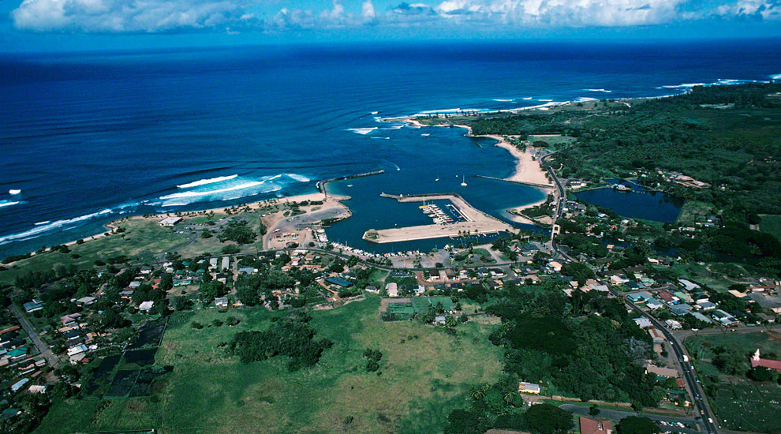
Puaʻena Point
Loko Ea Fishpond

Ahupuaʻa of Kawailoa
Loko Ea Fishpond/Ukoʻa Marsh
Puaʻena Point
Haleʻiwa

Table of Contents

What to Bring 3
Schedule 3
Field Trip Purpose & Objectives 4
Standards 5
Oli to Field Trip Sites 7
Geographic History of Kawailoa Area 8
History & Background of Kawailoa 9
About Loko Ea Fishpond 11
Breakout Session 1: Loko Ea Fishpond Tour & Observations 12
Breakout Session 2: Coral Reef & Tide Pool Investigation 18
Fish Identification Guide 24
Coral Identification Guide 26
Tide Pool Identification Guide 28
Limu Identification Guide 30
Fish and Weight Regulations 33

What to Bring

- 2-3 bottles of water
- Bathing suit/shorts with clothes that will be ok to be dirty
- Towel & extra clothes
- Shoes, tabis, or reef walkers (no slippers or crocs till after field trip)
- Snorkel gear (day students)
- Sunscreen
- Hat/Shades
- Snacks/Lunch
- Small Backpack
- Digital or phone camera (1 per group)
- Zip Lock back for camera (if it rains)
- 1 plastic bag for wet clothes
- Pencil & Workbook

Schedule

7:30-8:30 All groups leave

8:45-11:15 Breakout Session #1- Loko Ea Fishpond/ Ukoʻa Marsh
9:15-9:45 Station 1: Observations of Marsh and Fishpond
10:00-11:15 Station 2: Restoration of Marsh and Fishpond

11:30-12:00 Lunch

12:00-2:00 Breakout Session #2 – Animal Diversity Investigation
12:15-1:00- Station 3- Coral Reef Investigation
1:00-1:45- Station 4: Tide Pool Investigation

2:15- 3:00 Travel back to School

Field Trip Purpose & Objectives

Purpose:

“The purpose of the field trip is to observe and study the status and health of Loko Ea fishpond, Uʻkoa Marsh, and coral reef habitat in Haleʻiwa, North Shore.

Objectives:

- Students will use proper Hawaiian protocol to enter and present ho‘okupu (leis).

- Students will investigate the cultural significance and modern changes of the Kawailoa/Hale’iwa ahupuaʻa as Kamehameha Schools land.

- Students will identify and classify native vs. non-native animals.

- Students will compare and contrast traditional methods of conservation/preservation with modern methods.

- Student will investigate how human activity has affected the area in both positive and negative ways.

- Students will understand the significance of “education” and learn how fragile our ecosystems are.

- Students will perform Project Restoration and community service by restoring Loko Ea Fishpond and Ukoʻa Marsh.

- Students will report and submit their scientific findings in this field trip.

Standards

National Content Standards (Life Science 9-12)

Science as Inquiry

1.A. Gains an understanding that science is a process used to know more about the world around us.

1.B. Develops, practices, and applies the skills of questioning, observing, and experimenting.

1.C. Mathematics and technology are essential to scientific inquiry and for gathering data.

Interdependence of Organisms

2.A. Gains an understanding of the living world including form and function of organisms, diversity, life cycles, interactions and interdependencies.

2.B. The atoms and molecules on the earth cycle among the living and nonliving components of the biosphere.

2.C. Energy flows through ecosystems in one direction, from photosynthetic organisms to herbivores to carnivores and decomposers.

2.D. Organisms both cooperate and compete in ecosystems. The interrelationships and interdependencies of these organisms may generate ecosystems that are stable for hundreds or thousands of years.

2. E. Living organisms have the capacity to produce populations of infinite size, but environments and resources are finite. This fundamental tension has profound effects on the interactions between organisms.

2. F. Human beings live within the world's ecosystems. Increasingly, humans modify ecosystems as a result of population growth, technology, and consumption. Human destruction of habitats through direct harvesting, pollution, atmospheric changes, and other factors are threatening
current global stability, and if not addressed, ecosystems will be irreversibly affected.

Science in Personal and Social Perspectives

3.A. Populations grow and decline through the combined effects of births
and deaths, and through emigration and immigration. Populations can
increase exponentially, with the effects on resource use and environmental
pollution. (Example: Alien Invasive organisms)
3.B. Human populations use resources in the environment in order to maintain
and improve their existence. Natural resources have been and will continue
to be used to maintain human populations.

3.C. The Earth does not have infinite resources; increasing human consumption places severe stress on the natural processes that renew some resources, and it depletes those resources that cannot be renewed.

3.D. Many factors influence environmental quality.

3.E. Gains understanding of the role of science in his/her life including personal and community relationships, local and global challengers, and
environmental change.

‘Ike Hawai‘i Standards

- ʻŌlelo Hawai‘i
  - Students will Oli prior to entrance of the area.
- Hana No‘eau
  - Students will develop, practice, and apply the skills of observation, thinking, listening, imitating, modeling, experimenting, and questioning.
  - Understand our Hawaiian culture as a system of beliefs, knowledge, and practices shared by our people for the purpose of appreciation particular forms of arts.
- Ke Ao Nei
  - Through visiting the area students will understand and appreciate our relationship to our homeland from the perspective of the Hawaiian worldview and use this knowledge to care for our homeland.
- ‘Ohana
  - Students will work with classmates to understand traditional concepts of ‘ohana in terms of roles, responsibilities, practices, beliefs, and protocol.

WEO (Working Exit Outcomes)

- Ke Ao Hoʻoūlu (Growth)-
  - Embrace my identity as a Hawaiian
  - Grow by identifying strengths and needs and pursuing appropriate actions

- Ke Ao Pilina (Relationships)- Adapt successfully to various kūlana

- Ke Ao Lani, Ke Ao Honua (Global)-
  - Live in interdependence with all surrounds me physically, spiritually, emotionally, and intellectually.
  - Embrace the collective experience as Hawaiʻi and the Pacific as a foundation for relating to the diversity of the world.
  - Nurture and value my identity as a source of understanding, purpose, meaning, and connection to others
- Ke Ao ʻImi Naʻauao- Knowledge and Wisdom
  - Utilize various sources (kupuna, kumu, moʻolelo, wahi pana, etc.) to foster inquiry and seek knowledge
  - Engage in critical thinking to apply traditional knowledge to my contemporary context

Oli to Field Trip Sites

E Hömai

E hömai ka ‘ike mai luna mai ē
ʻO nä mea huna no‘eau o nä mele ē
E hömai, e hömai, e hömai ē (repeat 3x)

Grant me knowledge from above
Of the Elusive words of wisdom within the chants
Grant me, grant me, grant me

Oli Kähea

Kü äkea nä kamalei
I ke anu o ka ‘öpua
Nä pua Kukui a Pauahi
I ke ao mälamalama
E maläma mai, e maläma mai ‘ē

The beloved children (of Pauahi) stand openly
In the chill of the billowing clouds
Kukui blossoms of Pauahi
Take care of us, take care of us…

Oli Mahalo

ʻUhola ʻia ka makaloa lā
Pū ʻai i ke aloha ā
Kū kaʻi ʻia ka hā loa lā
Pāwehi mai nā lehua
Mai ka hoʻokuʻi a ka hālāwai lā
Mahalo e Nā Akua
Mahalo e nā kupuna lā, ʻeā
Mahalo me ke aloha lā
Mahalo me ke aloha lā

The makaloa mat has been unfurled
In love, (food is/was shared) we share
The great breath has been exchanged
Honored and adorned is the Lehua
From zenith to horizon
Gratitude and thanks to our Akua
Gratitude and thanks to our beloved ancestors
Gratitude, admiration, thanks, and love
To all who are present, both seen and unseen

Geographic History of Kawailoa Area

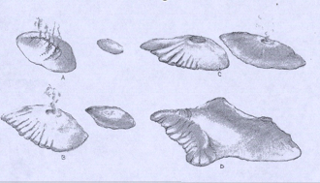
The volcanoes of the Hawaiian Island chain are called shield volcanoes, for their gently rounded, dome-shaped profiles. Shield volcanoes are built of lavas that erupt quietly, with little explosion, and spread rapidly from the vent and are called basaltic rocks.

The two volcanoes that made O‘ahu were Wai‘anae Volcano and Ko‘olau Volcano (Figure 1). The present island of O‘ahu came into being about 10 million years ago when the top of the Wai‘anae volcano broke the surface of the Pacific. So, the Waiÿanae volcano is much older than the Ko‘olau volcano. The caldera (or crater) of the Wai‘anae volcano sank to form a broad crater and with erosion, caused the valleys of the Western side of Oÿahu on the Wai‘anae side to become much bigger than those on the Schofield side.
Figure 1: Volcanic activity of Waiÿanae and Koÿolau Volcanoes of Oÿahu

The Ko‘olau volcano appeared a few million years later as a separate island a few miles of the Wai‘anae. Both the Wai‘anae and Ko‘olau continued erupting causing for lava flow. The eruptions of both volcanoes formed more land eventually unifying to form one single island. Then, the Wai‘anae volcano became extinct and so did the Ko‘olau volcano. Like the Koʻolau volcano, the caldera (or crater) of the Waiʻanae volcano also sank below the ocean. With time, rain, and erosion, the remaining slopes of the Waiʻanae and Koʻolau volcano became more steep and jagged (Figure 2). So, Kawailoa ahupuaʻa runs from the mauka slopes of Koʻolau mountain range to the ocean.

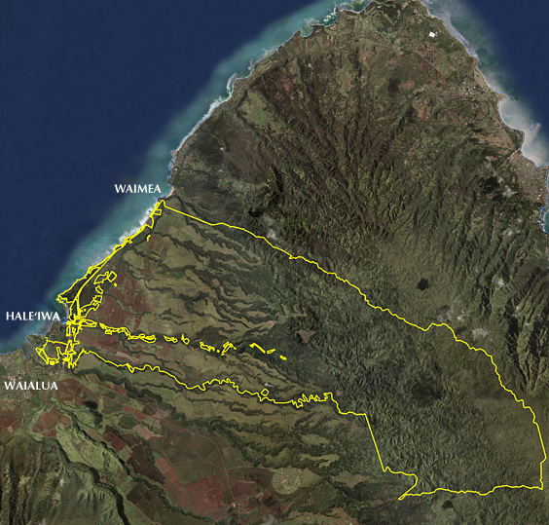

Koʻolau
Mountains

Waiʻanaeʻ mountains

Figure 2: Kawailoa Ahupuaʻa with Koʻolau mountains and Waiʻanae mountains.

History & Background of Kawailoa

Land Legacy- North Shore O’ahu

The six ahupuaʻa of Paʻala, Kawailoa, Lauhulu, Kuikuiloloa, Punanue, and Kapaeiloa are part of the land legacy that was passed down to Ke Aliʻi Bernice Pauahi and traceable to the lineages of the Kohala and Kona chiefs that aided Kamehameha I in the unification of the Hawaiian Islands. In the Māhele, Victoria Kamāmalu claimed title to these lands. After she passed, title was given to Ruth Keʻelikolani and then finally to Bernice Pauahi in 1884.

All six ahupuaʻa are in the moku of Waialua. These vast lands constitute one of the largest contiguous ahupuaʻa (Kawailoa) and watershed areas on Oʻahu in its relatively natural state. The total acreage of these lands is approximately 26,200 acres with roughly 15,000 acres in conservation lands, 9,000 acres in agricultural lands, and 2,200 acres in rural lands.
The Six Ahupuaʻa
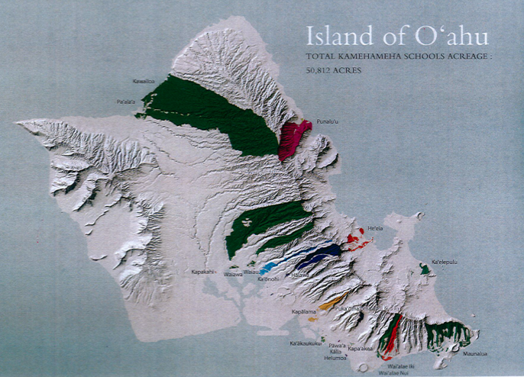
Haleʻiwa
Kawailoa
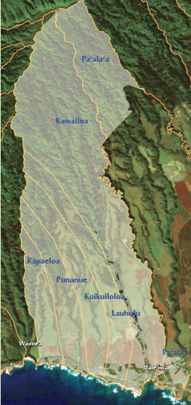
Kawailoa Ahupuaʻa:
The word Kawailoa means “the long waters”. The name comes from Kawailoa Stream, one of the largest streams on Oʻahu, which originates in the Koʻolau Range and merges with the Anahulu River at sea level. This ahupua‘a extends over a broad area with its southern peninsula on the south end, ranging north to portions of the Koʻolau Mountains.
Kawailoa today consist of a diversified use from 25,000 acres of agriculture lease land, 1,033 acres of lease land to Monsato for growing Genetic Modified Crops (GMO), alternative energy by First Wind (wind farms), commercial development of Haleʻiwa town, ʻāina based education via Loko Ea Fishpond restoration, formation of Sustainability Institute, and partnership to restore Archaeological sites.

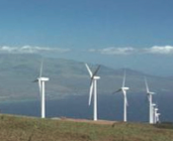
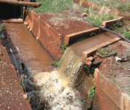
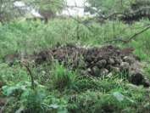
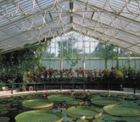
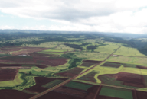

Nā Moʻolelo
Kaʻopulupulu (Waimeaʻs Priest- Kahuna nui)
During the reign of Kahahana, who became ruler of Oahu in 1773, Waimeaʻs presiding priest was Kaʻopulupulu. Many legends and stories recount the life of this famous prophet. In one legend, Kahahana asked his priest to determine whether the gods approved of him, and whether the island of Kauaʻi would surrender if he invaded its shores. Kaʻopulupulu requested that a temple be built where he could “speak to the great chief Kekaulike (of Kauaʻi) through the thoughts of the great akua Mahuka.”At first, Heiau Kupopolo was built on the beach of Waimea Bay; however, when Kaʻopulupulu used it, he received no answer from Kauai (see detailed info below on Heiau). It was thought the temple was in the wrong location. Because the kahuna believed that “thoughts are little gods, or kupua, that travel in space, above the earth … they fly freely as soaring birds,” he called on the people to build a second temple high upon the cliffs. This was to become Heiau Puʻu o Mahuka (see info below). From the temple, Kaʻopulupulu sent out thought waves, and the answer quickly returned – Kauaʻi wished for peace.
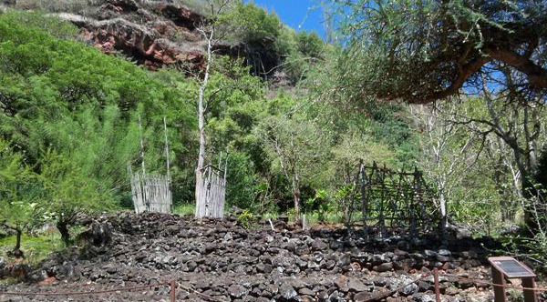
Kupopolo Heiau
Kupopolo Heiau, one of the most significant wahi kūpuna (ancestral places) remaining in the ahupua‘a of Kawailoa on O‘ahu’s North Shore. The Oʻahu chief Kahahana who contemplated invading Kauaʻi, built Kupopolo Heiau. Not receiving a sign at Kupopolo, he asked another heiau be built more upland where his kahuna nui-Kaʻopulupulu eventually indicated that the peace should be maintained, a prophecy. “It is far better to sleep in the sea: for from the sea comes life, or the means of living” is said to have originated from. This prophecy was interpreted as fulfilled several times: when Kahekili conquered Oʻahu; Kamehameha’s coming from Hawaiÿi; and from the arrival of foreigners.

Puʻu o Mahuka Heiau

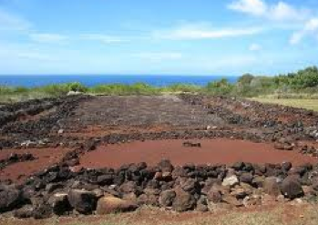
Puʻu o Mahuka Heiau is the largest heiau on Oʻahu covering almost 2 acres. The name is translated as “hill of escape.” In the 1770s, high priest Kaʻopulupulu under Oʻahu chief Kahahana, oversaw the heiau. This was a time of political upheaval and it is likely that the heiau was used as a luakini (sacrificial temple), perhaps for success in war. In 1795, when Kamehameha I conquered Oʻahu, his high chief Hewahewa conducted religious ceremonies at this heiau. The use of Puʻu o Mahuka continued until 1819 when the traditional Hawaiian religious practice was abolished due to Christianity.

Puaʻena Point

The ancestral belief is that Puaʻena serves as a leina, an area of the physical realm where the souls of the departed pass on into their afterlife known as “leaping of souls”. This site has an associative linkage, both in name and cultural function, to Kaʻena Point, which is also a leina, located on the lae that joins the moku of Waialua and Waiʻanae. In modern times Puaʻena has been the site of a military airfield.

About Loko Ea Fishpond Haleʻiwa
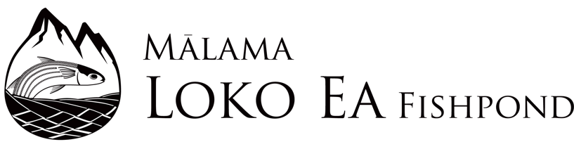
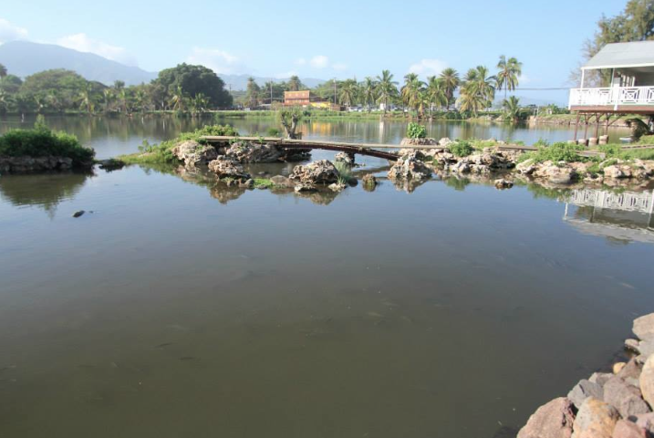
Mālama Loko Ea is a non-profit organization providing the community with educational opportunities that are integrated with traditional and contemporary Hawaiian knowledge. The loko iʻa fishpond traditionally named Loko Ea is a rare, cultural site nestled in the quaint town of Haleʻiwa on Oʻahu’s North Shore. It is located in the ahupuaʻa of Kawailoa, a land division from mountain to sea, in the moku land district of Waialua. The area is traditionally known for its profusion of fresh water springs. Famous was the moku of Waialua for its abundance and fertility, where mahiʻai farmers and kanaka lawaiʻa fishermen could sustain their families with bountiful harvests.
The Mission at Loko Ea Fishpond is to restore, protect and preserve Loko Ea as an ecosystem in order to ensure sustainable living and the preservation of Hawaiian culture through the advocacy of education and stewardship. The foundation of Mālama Loko Ea was founded in 2009. Home based in Kawailoa Ahupuaʻa with land owned by Kamehameha Schools.
History of Fishponds
Fishponds were originally created by aliʻi (chiefs) as stocking ponds to raise fish and provide for easy access to fish during the winter months when deep-sea fishing was dangerous. There were many different types and sizes of fishponds, depending on the resources available for construction and the amount of people that the pond had to support. Both Loko Ea and ʻUkoʻa fishponds are two important cultural resources for food production that contributed to the abundance and wealth of Waialua being known as an ʻāina momona (fattened land). In pre-contact times, these royal ponds were linked to aliʻi (chiefs) and were controlled production from the adjacent landscape of Waialua, linked to three ʻaumākua or ancestral deities that are considered guardians and protectors for the pond areas. These guardians brought blessings of abundance of fish, and health to the people, and preserved the welfare of the ʻohana (families) of Waialua. These deities include the shark god Niukala, and the eel god Puhiʻula, but most famous was the large moʻo (lizard) named Laniwahine.
Moʻolelo
“Laniwahine was the guardian (kiaʻi) of ʻUkoʻa at Waialua, and ʻUkoʻa was regarded as the long house (hale hālau) where she lives. She was a native of ʻUkoʻa and all her deeds centered about that place. The “native sons” (keiki kamaʻāina) of ʻUkoʻa never failed to recognize her deeds, but few of her descendants are now left or perhaps none. ʻUkoʻa was a very strange fishpond in which lived extraordinary fishes. A fish might be a kumu fish on one side and on the other side a mullet; or on one side weke pueo, and on the other mullet; or on one side might be a silver white like a shite cock; when scaled, the skin might be stripped and variegated inside. It was blear to all her descendants that these strange fish belong to Laniwahine and it was not right to eat them. But the mullet of ʻUkoʻa were full of fat when, as in all such pond, the native guardian of the pond was remembered.---By Samuel Kamakau 1865.
Station 1: Loko Ea Fishpond/Ukoʻa Marsh

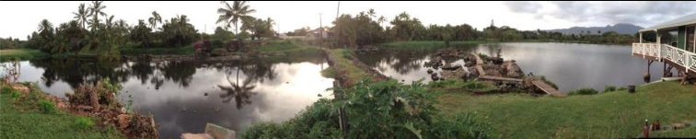

Specifics of Loko Ea Fishpond are:

Location: Ahupuaʻa of Kawaialoa, district of Haleʻiwa, Hawaiʻi
Size: 9.79 acres with 3 connected ponds, each with special features, design, and management needs. The pond has been modified in modern times and reinforced with cement and soil fill to strengthen the kuapā.
- Pond 1: The smallest pond is 1/4 acres, which is used to nurse fingerlings or small fishes.
- Pond 2: About 3/4 acres that serves to connect Loko Ea to ʻUʻkoa pond.
- Pond 3: The largest of three ponds at 6 acres
- Auwai- Pathway to each ponds
- Makahā- Gates for the ponds

Depth: 2-5 feet, depending on the tide (low, high, or mid-tide).

Water type: brackish environment, fed by springs and Haleʻiwa Beach.

Question: What is the animal diversity at Loko Ea Fishpond and Ukoʻa Marsh?

Hypothesis: ____________________________________________________________
__________________________________________________________________________________

I. Observations Kingdom Animalia- Vertebrate
Instructions: Use your observations to find out what type of animal life is found in each of the ponds by filling in the data table below.
Site A- Small Pond Site C- Large Pond Terrestrial= Land Animals Sediment= Ground
Site B- Medium Pond Site D- Auwai & Makahā Aquatic= Water Animals

Origin: E=Endemic, I= Indigenous, A= Alien, AI= Alien Invasive, PI= Polynesian Introduced

Table 1: Types of vertebrates found in Loko Ea Fishpond/Ukoʻa Marsh Site: _____

Date:  Time: |  | Weather:
List of vertebrate animals found by common name | Abundance:  Abundant (+++)  Common (++)  Rare (R) | Origin  (E, I, A, AI, PI) | Species Type:  Terrestrial=T  Aquatic=A  Sediment= S  Or Combination | Trophic Level:  Decomposer  Herbivore  Omnivore  Carnivore | Indicate the Class of each vertebrate animal:  Osteichthyes (fish)  Amphibia (frogs, tadpoles)  Reptilia (lizards, geckos, Jackson chameleon)  Aves (birds, ducks, chickens)  Mammalia (pigs, rats, dogs, mongoose, cats, etc.) | Scientific Name  of Organism

II. Observations Kingdom Animalia- Invertebrate
Instructions: Use your observations to find out what type of animal life is found in each of the ponds by filling in the data table below.
Site A- Small Pond Site C- Large Pond Terrestrial= Land Animals Sediment= Ground
Site B- Medium Pond Site D- Auwai & Makahā Aquatic= Water Animals

Origin: E=Endemic, I= Indigenous, A= Alien, AI= Alien Invasive, PI= Polynesian Introduced

Table 2: Types of Invertebrates found in Loko Ea Fishpond/Ukoʻa Marsh. Site: _______

Date:  Time: |  | Weather:
List of invertebrate animals found by common name | Abundance:  Abundant (+++)  Common (++)  Rare (R) | Origin  (E, I, A, AI, PI) | Species Type:  Terrestrial=T  Aquatic=A  Sediment= S  Or Combination | Trophic Level:  Decomposer  Herbivore  Omnivore  Carnivore | Indicate the Phylum of each invertebrate animal:  Platyhelminthes (flatworms)  Mollusca (snails, slugs, opihi)  Annelida (earthworms)  Arthropoda (shrimp, crayfish, insects, bugs, crabs, etc) | Scientific Name  of Organism

Analysis Questions: Answer using complete sentences.

- Although fishponds are an ancient Hawaiian aquaculture practice, many are being restored today. Why and how are fishponds beneficial to Hawaiʻi today?

- What does a “kuapā” mean and what is a kuapā made of for Loko Ea fishpond?

- What is a mākahā and how does it help with water circulation and cultivation of fish? How many mākahā does Loko Ea fishpond have?

- How do the tides affect the fish and water flow of the fishpond?

- Using your data in tables 1 and 2 which type of vertebrate fish dominated small pond, medium pond, large pond, and auwai? Is this fish a threat or good for the fishpond? If fish is a threat, then how might it be resolved or fixed?

- Using your data table 1 and 2, which type of invertebrate dominated small, medium, large pond, and auwai? Is this invertebrate a threat or good for the fishpond ecosystem? (Explain)

- Using your data in tables 1 and 2, create 5 food chains that are in effect in each of the area of the pond?

Auwai (5 food chains)

Small Pond (5 food chains)

Medium Pond (5 food chains)

Large Pond (5 food chains)

- Based on the class data observations and data, does Loko Ea fishpond have a healthy diversity of living things? Explain?

- Based on the class data observations and data, does Ukoʻa Marsh landing have a healthy diversity of living things? Explain?

- How did your fishpond experience strengthen your knowledge about “utilizing various sources (i.e. kupuna, kumu, loea, moʻolelo, wahi pana, moʻomeheu) to foster inquiry and to seek knowledge” (KS WEO)?

Station 2: Coral Reef & Tide Pool Investigation

Instruction: A wide range of animal species occupy Puaʻena Point area. For the purpose of the Zoology section, you will focus only on the animal species near or along Puaʻena Beach at the facility we are visiting today. You will record the presence of species by visual observation, photography (phone or other cameras), sketches, lists, and collecting samples using nets and buckets. You will make an effort not to harm any of the organisms and when finished with our observations, return them gently to the location where found to minimize our impact. Each organism plays an important role in the environment that we wish to respect.

Preparation prior to the Field Trip. Persons per group = 3-4
- Get acquainted with your role. Research and read the student data book and online sources to discover how a
  - Protista/Limu
  - Vertebrate Zoologist
  - Invertebrate Zoologist
contributes to the well being of natural areas. Be able to say three things about their job
and how they provide a service to the community and help us personally.

- Tell other group members about your role. Define new terms and use them when describing your “profession.”

- Be prepared to help out and fill in if someone in your group is absent so that all tasks are completed during our field study. As a group, you will be ready to share with the class during our post-trip sessions.

Group Roles:

1) Group 1- Protista/Limu

Purpose: To count type of various limu and seaweed in the marine habitat and take photos of types of limu found.

- Equipment checklist: camera, clipboard, student data book, pencil, quadrats, and dip/nets.

- Group 2- Vertebrate Zoologists

Purpose: To count and collect animals with backbones such as fish, turtles, dolphins, sharks, seabirds, etc.

- Assess fish and other vertebrate abundance. Sample ocean animals and assess species composition, for fish using dip nets. If you capture invertebrate species as by-catch, share them with the invertebrate zoologists.

- Equipment checklist: clipboard, student data book, pencil, aquatic dip nets, camera, quadrats, bucket, animal cage/aquaria.

3) Group 3- Invertebrate Zoologists

Purpose: To count and collect animals without backbones such as mollusks, shrimp, sponges, coral, squids, octopus, clams, shells, etc. Collect specimens with aquatic dip nets, and benthic (ocean bottom). Look inside coral and beneath rocks along where small organisms can hide. Conduct visual observations and take pictures of aquatic vertebrates.

- Equipment checklist: camera, clipboard, student data book, pencil, dip nets, camera/phone, quadrats, bucket, animal cage/aquaria.
Group Research Question: Your group question should relate to diversity of the environment or correlation of species in the area to the food supply. Each group should have a different question.

__________________________________________________________________

- Why does this research question interest your group?

- Does this research question relate to Hawaiian perspective or cultural knowledge?

Hypothesis:

Materials

- What materials will your group need in order to conduct the experiment?
(List or bullet point them below)

Procedures:

- Which area will your group collect the data of animal life (Tide pool, strand zone, ocean)

- What data tables and graphs are needed to conduct the experiment?

Data Table: Vertebrates- Coral Reef & Tidepool

Table 1: Types of vertebrates found in Puaʻena Point.
Date:  Time: |  | Weather:
List of vertebrate animals found by common name | Abundance:  Abundant (+++)  Common (++)  Rare (R) | Origin  (E, I, A, AI, PI) | Species Type:  Terrestrial=T  Aquatic=A  Sediment= S  Or combination | Trophic Level:  Decomposer  Herbivore  Omnivore  Carnivore | Indicate the Class of each animal:  Osteichthyes (fish)  Amphibia (frogs)  Reptilia (Turtles)  Aves (birds)  Mammalia (seals, mongoose, humans) | Scientific Name  of Organism

Data Table- Invertebrates- Coral Reef & Tide pool

Table 2: Types of Invertebrates found in Puaʻena Point.
Date:  Time: |  | Weather:
List of invertebrate animals found by common name | Abundance:  Abundant (+++)  Common (++)  Rare (R) | Origin  (E, I, A, AI, PI) | Species Type:  Terrestrial=T  Aquatic=A  Sediment= S  Or combination | Trophic Level:  Decomposer  Herbivore  Omnivore  Carnivore | Indicate the Phylum of each invertebrate animal:  Porifera (Sponges)  Cnidaria (jellyfish, p-man-war, coral)  Platyhelminthes (flatworms)  Mollusca (octopus, opihi)  Echinodermata (urchins, sea star)  Arthropoda(shrimp, lobster) | Scientific Name  of Organism

Data Table- Protista/Limu- Coral Reef and Tidepool

Table 3: Types of Limu/Seaweed found in Puaʻena Point.

Date:  Time: |  | Weather:
List of Limu/Seaweeed animals found by common name | Abundance:  Abundant (+++)  Common (++)  Rare (R) | Origin  (E, I, A, AI, PI) | Species Type:  Terrestrial=T  Aquatic=A  Sediment= S  Or combination | Trophic Level:  Decomposer  Herbivore  Omnivore  Carnivore  Producer | Phylum name: | Scientific Name  of Organism

Analysis & Conclusion

1. Make bar graphs on your final report to show diversity and quantity of each type of group (protists/limu, vertebrates, and invertebrates).

2. What did you find about your study about Puaʻena point diversity of life? Was your group hypothesis supported or not? Explain.

3. What human factors and activities are affecting the diversity of species in the area? How do these human impacts affect the diversity of life and the ecosystem?

FISH ID CARD
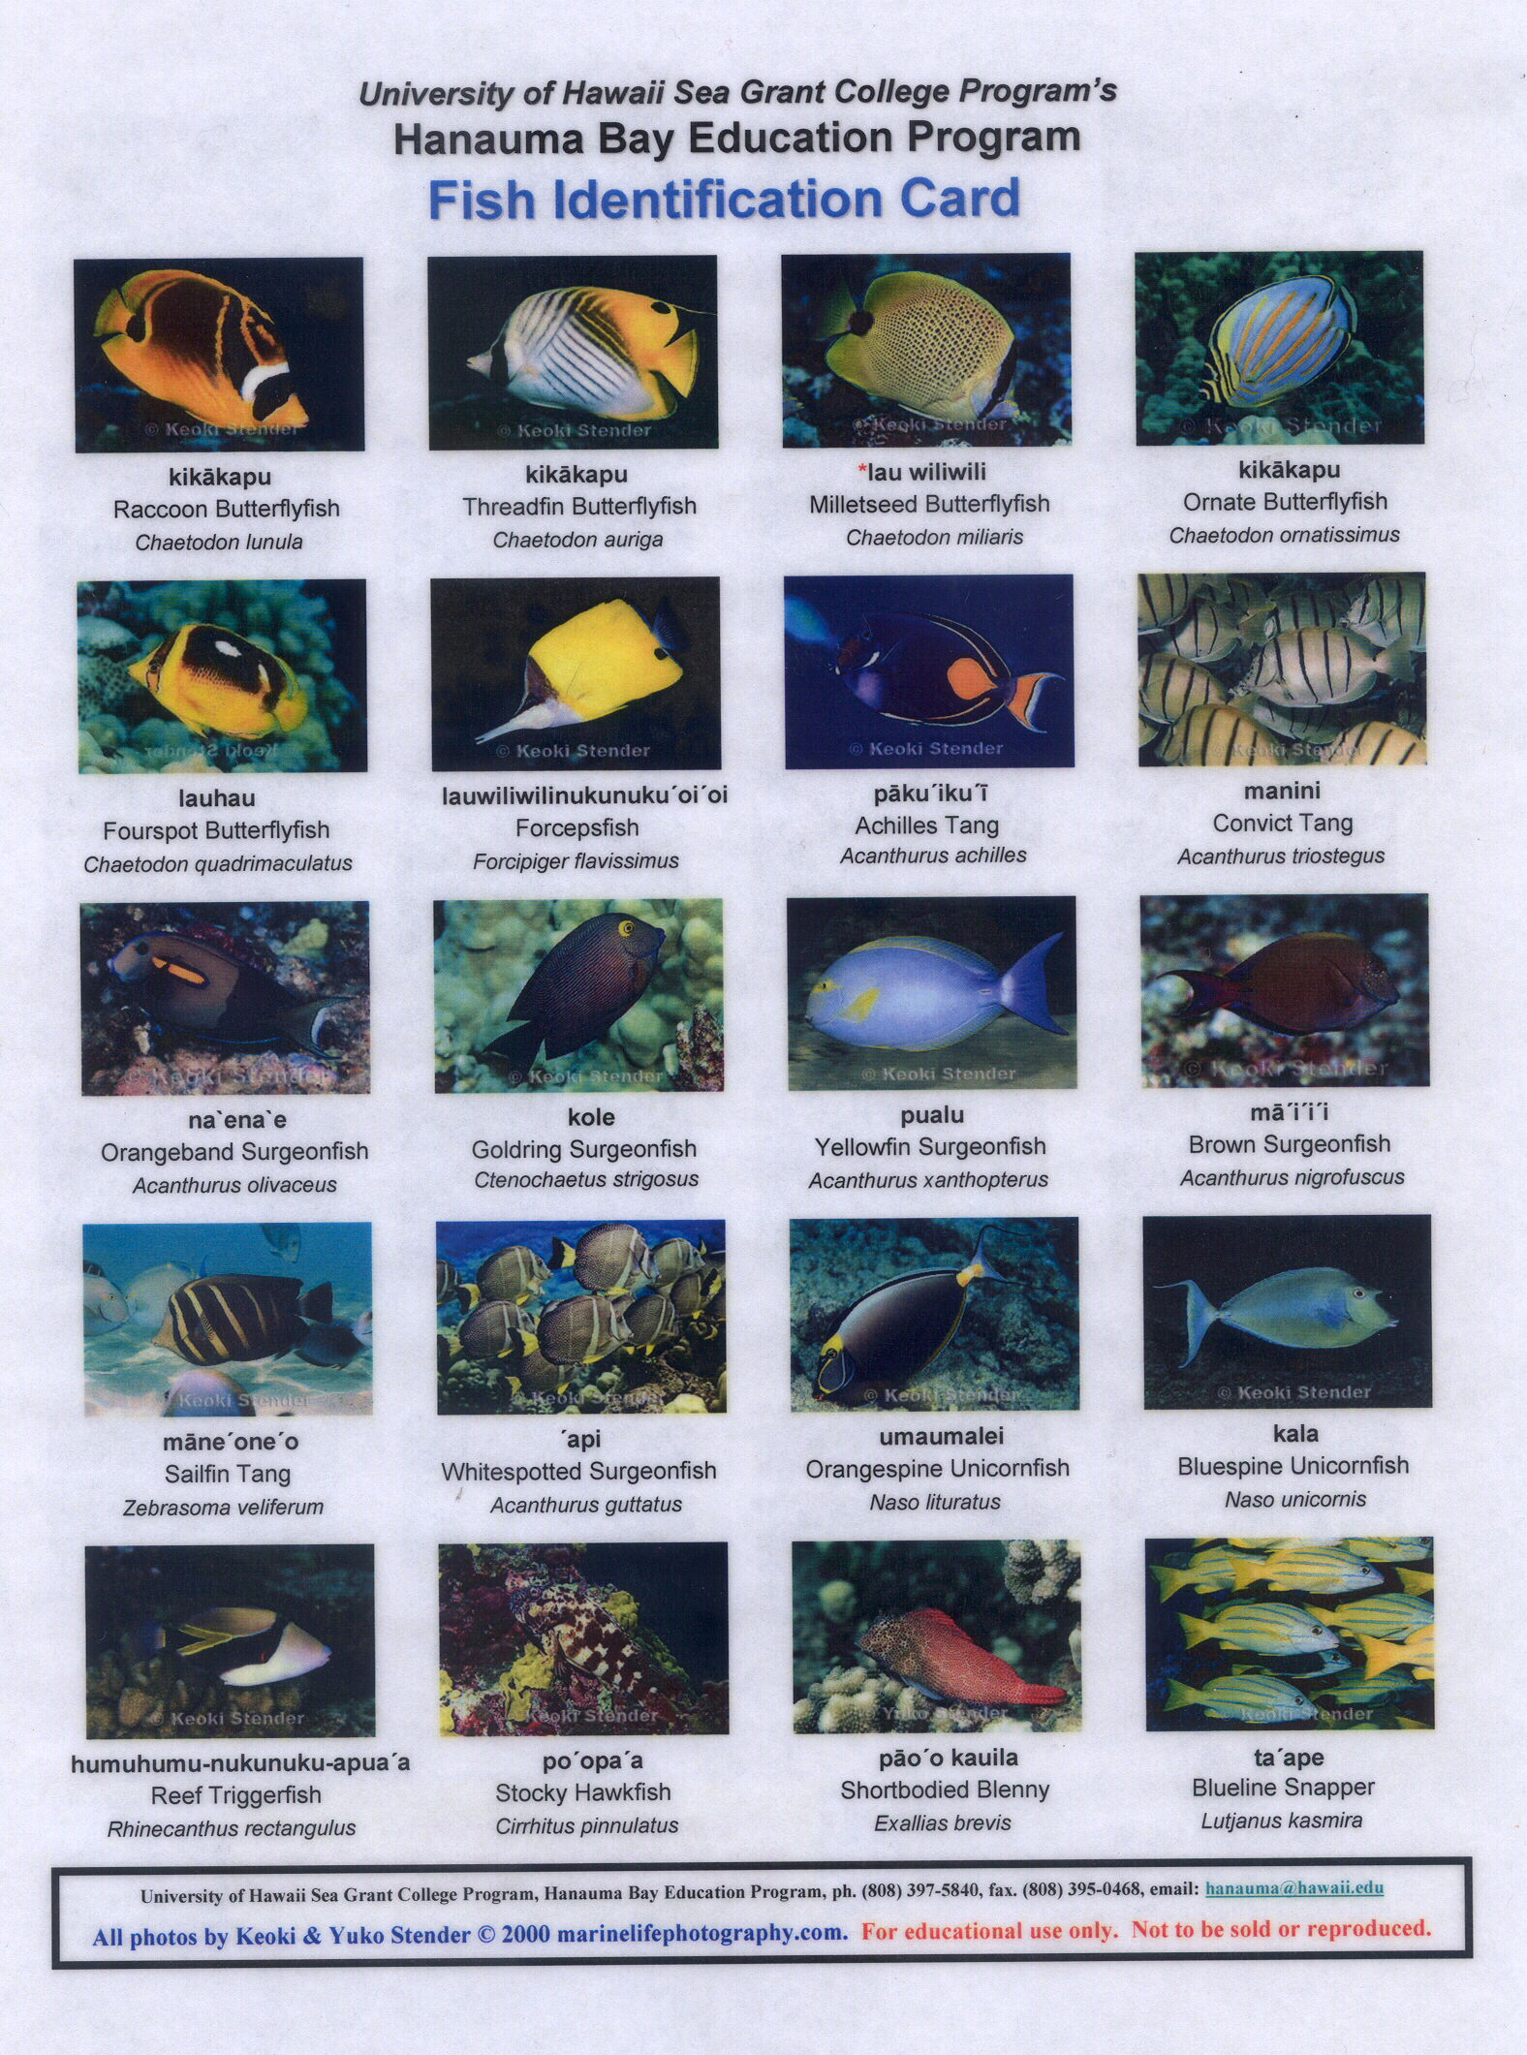

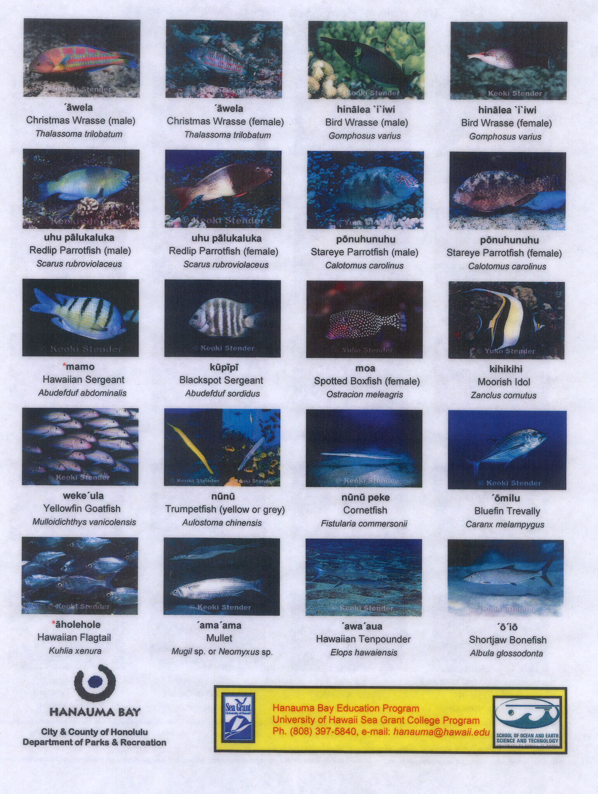
Coral ID Card
Phylum Cnidaria

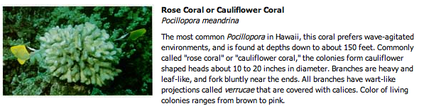

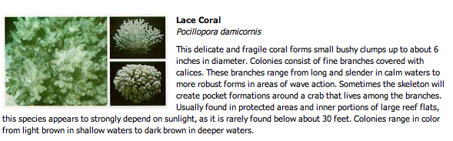

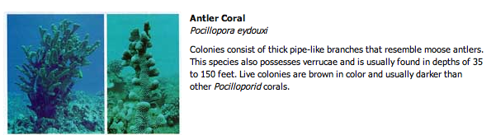

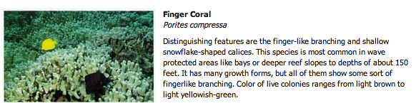

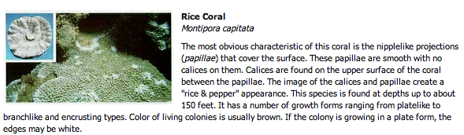

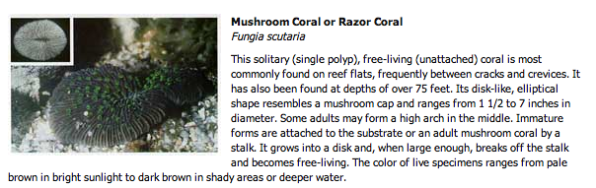

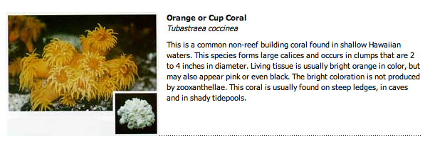

TIDE POOL AND SHALLOW REEF IDENTIFCATION
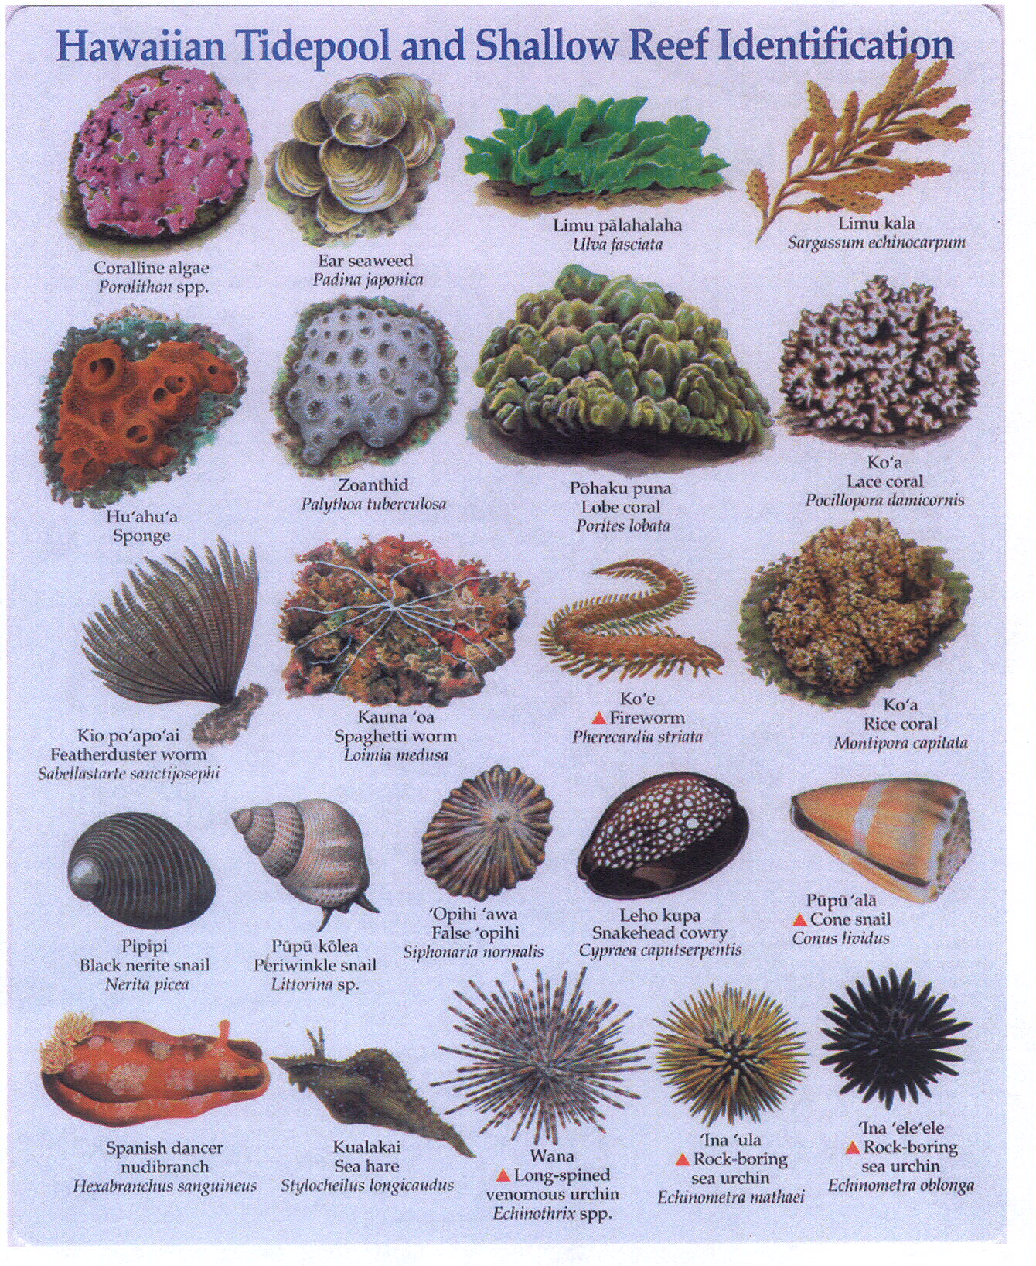

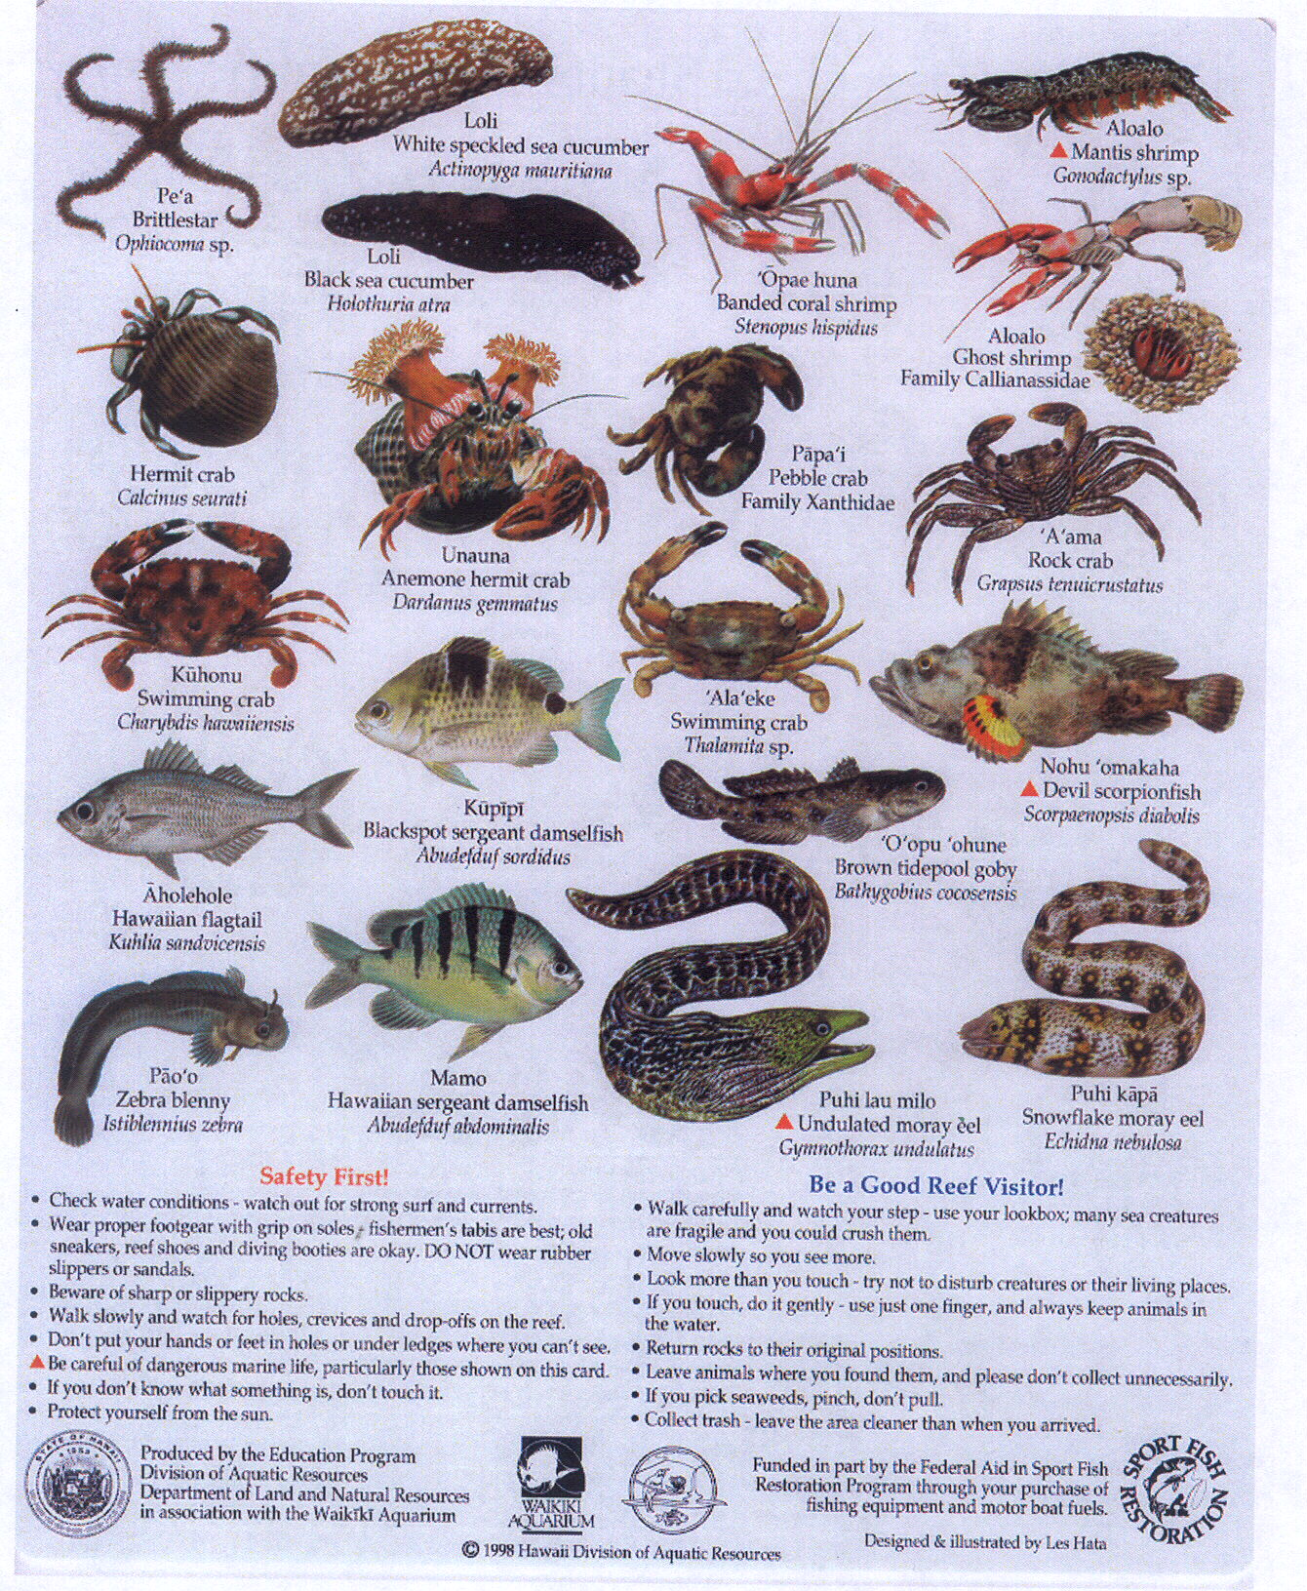
Limu of Hawaiʻi

How to Use the Field Guide
What's in a name: Most of our Hawaiian algae do not have common names, except for the edibles that have Hawaiian names. The Latin name is comprised of two parts: the genus name groups related an alga while the species name is unique to that particular plant. Example: (genus) Halimeda opuntia (species)

Group Classifications: The alien and native macro algae included in this guide are from 3 major groups of marine algae. The group classifications are based upon photosynthetic pigments and give the algae their characteristic colors: the Chlorophyta (green algae), Rhodophyta (red algae) and Phaeophyta (brown algae).

Features: Key features of each alga are listed, providing a quick reference for identification in the field. Unique or defining characteristics, color and habitat are noted.

Color Legend: Chlorophyta= Green Rhodophyta= Red Phaeophyta= Brown

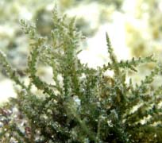
1. Acanthophora spicifera (Rhodophyta) (Alien Invasive)
Native Look-alike: Laurencia spp.
Features:
Spine like branches
Red, brown to yellow in bright sunlight
Intertidal, shallow reef flats
Most successful alien

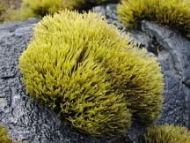
2. Ahnfeltiopsis coccina limu aki`aki (Rhodophyta) (Native)
Features:
Thick erect, cylindrical blades
Thick clumps attached to basalt
Bright yellow in sun to dark brown in shade
High wave exposure
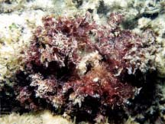
3.(Melan) Amansia glomerata* (Rhodophyta) (Native)
Features:
Semi-transparent blades in rosettes
Blades with midribs, serrated edges
Tough, stem-like stalk
Dark maroon red
High wave exposure

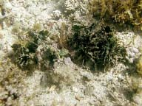
4. Avrainvillea amadelpha (Chlorophyta) (Unknown)
Features:
Wedge-shaped, loosely woven spongy blades
Densly clustered blades
Green to gray-green
Calm, sandy bottoms
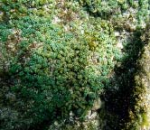
5. Caulerpa racemosa (Chlorophyta) (Native)
Features:
"Grape-like"- spherical branchlets
Thick clusters
Light green
Tide pools and reef flats

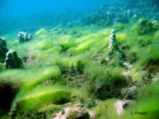
6. Cladophora sericea (Chlorophyta) (Native)
Features:
Very fine, delicate
Wispy, feather-like
Bright green
Low intertidal to subtidal
Forms large blooms in west Maui

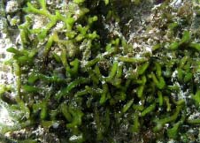
7. Codium edule limu wawae'iole (Chlorophyta) (Native)
Features:
Soft, spongy to touch
Forked branches
Dark green
Lies prostrate, frequently attached to substrate and rubble

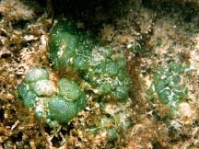
8. Dictyosphaeria spp. (Chlorophyta) (Native)
Features:
Convoluted mass
Large, "bubble" cells

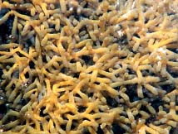
9. Gracilaria salicornia (Rhodophyta) (Alien Invasive)
Native Look-alike: Codium edule
Features:
Brittle, easily fragments
Short, pointed side branches
Yellow to dark red
Calm, intertidal and shallow reef flats

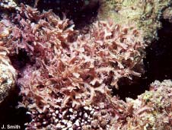
10. Galaxaura marginata (Rhodophyta) (Native)
Features:
Flattened, calcified blades with raised margin
Chalky pink to red
Intertidal to subtidal

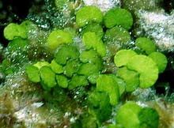
11. Halimeda opuntia (Chlorophyta) (Native)
Features:
Thick kidney-shaped blades
Calcified
Green to chalky white
Large spreading plants subtidally

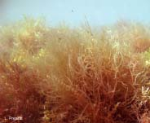
12. Hypnea musciformis (Rhodophyta) (Alien Invasive)
Native Look-alike: Pterocladiella spp.
Features:
Tips flattened, with "hooks"
Short, pointed side branches
Yellow to dark red
Calm, intertidal and shallow reef flats

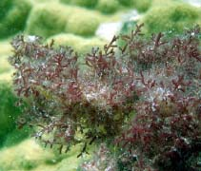
13. Laurencia spp. limu mane`one`o (Rhodophyta) (Native)
Features:
Pits in end of branches
Pink-purple to red or green
Intertidal to subtidal

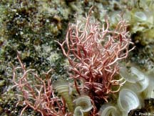
14. Liagora spp. (Rhodophyta) (Native)
Features:
Calcified, often soft and slippery
Forked branching
Tan to pink to brown
Intertidal to subtidal

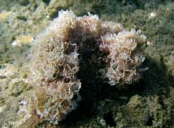
15. Martensia fragilis (Rhodophyta) (Native)
Features:
Delicate, flat blade
Alternating blade and mesh portions
Iridescent pink or blue
Low intertidal to subtidal

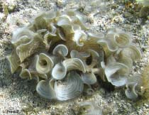
16. Padina spp. (Phaeophyta) (Native)
Features:
Flat calcified blade with rings
Chalky white to light yellow-brown
Bright yellow in sun to dark brown in shade
Intertidal and subtidal

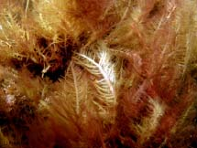
17. Pterocladiella capillacea (Rhodophyta)(Native)
Features:
Strap-shaped blades
Opposite branching, pinched at base
Dark red to green
Often single species mats

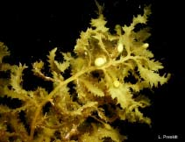
18. Sargassum echinocarpum limu kala (Phaeophyta) (Native)
Features:
Thick, spiny blades
Gas bladders
Golden to dark brown
Intertidal, wave exposure

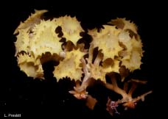
19. Turbinaria ornata (Phaeophyta) (Native)
Features:
Stiff, erect turban-like blades with spines
Light yellow brown
Very common
High intertidal to subtidal

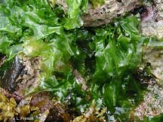
20. Ulva fasciata limu pālahalaha (Chlorophyta) (Native)
Features:
Flat, thin, sheet-like
Thick clumps attached to basalt
Bright green
Intertidal and reef flats, areas of high wave exposure

Fish Size & Weight Regulations
